ISLR

# 2.3 Introduction to R

## 2.3.1 Basic Commands

x <- c(1,3,2,5)  
x

## [1] 1 3 2 5

x <- c(1,6,2)  
x

## [1] 1 6 2

y <- c(1,4,3)

length(x)

## [1] 3

length(y)

## [1] 3

x+y

## [1] 2 10 5

ls()

## [1] "x" "y"

rm(list=ls())

x <- matrix(data=c(1,2,3,4),nrow=2,ncol=2)  
x

## [,1] [,2]  
## [1,] 1 3  
## [2,] 2 4

x <- matrix(c(1,2,3,4),2,2)  
x

## [,1] [,2]  
## [1,] 1 3  
## [2,] 2 4

matrix(c(1,2,3,4),2,2,byrow=TRUE)

## [,1] [,2]  
## [1,] 1 2  
## [2,] 3 4

sqrt(x)

## [,1] [,2]  
## [1,] 1.000000 1.732051  
## [2,] 1.414214 2.000000

x^2

## [,1] [,2]  
## [1,] 1 9  
## [2,] 4 16

x <- rnorm(50)  
y <- x + rnorm(50,mean=50,sd=0.1)  
cor(x,y)

## [1] 0.9956469

set.seed(1303)  
rnorm(50)

## [1] -1.1439763145 1.3421293656 2.1853904757 0.5363925179 0.0631929665  
## [6] 0.5022344825 -0.0004167247 0.5658198405 -0.5725226890 -1.1102250073  
## [11] -0.0486871234 -0.6956562176 0.8289174803 0.2066528551 -0.2356745091  
## [16] -0.5563104914 -0.3647543571 0.8623550343 -0.6307715354 0.3136021252  
## [21] -0.9314953177 0.8238676185 0.5233707021 0.7069214120 0.4202043256  
## [26] -0.2690521547 -1.5103172999 -0.6902124766 -0.1434719524 -1.0135274099  
## [31] 1.5732737361 0.0127465055 0.8726470499 0.4220661905 -0.0188157917  
## [36] 2.6157489689 -0.6931401748 -0.2663217810 -0.7206364412 1.3677342065  
## [41] 0.2640073322 0.6321868074 -1.3306509858 0.0268888182 1.0406363208  
## [46] 1.3120237985 -0.0300020767 -0.2500257125 0.0234144857 1.6598706557

set.seed(3)  
y <- rnorm(100)  
mean(y)

## [1] 0.01103557

var(y)

## [1] 0.7328675

sqrt(var(y))

## [1] 0.8560768

sd(y)

## [1] 0.8560768

## 2.3.2 Graphics

x <- rnorm(100)  
y <- rnorm(100)  
plot(x,y)

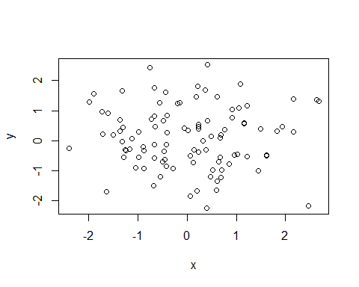

plot(x,y,xlab="this is the x-axis",ylab="this is y-axis",main="Plot of X vs Y")

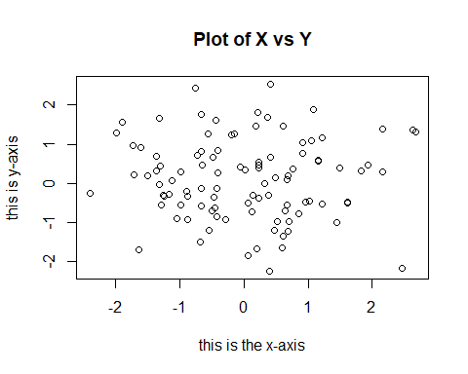

pdf("Figure.pdf")  
plot(x,y,col="green")  
dev.off()

## png   
## 2

x <- seq(1,10)  
x <- seq(-pi,pi,length=50)

y <- x  
f <- outer(x,y,function(x,y)cos(y)/(1+x^2))  
contour(x,y,f)  
contour(x,y,f,nlevels=45,add=T)

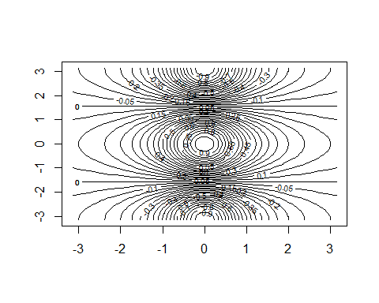

fa <- (f-t(f))/2  
contour(x,y,fa,nlevels=15)

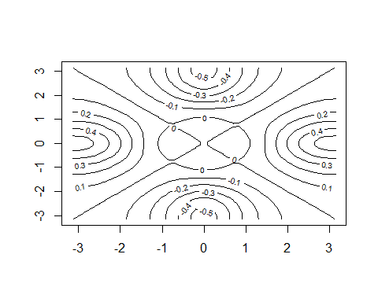

image(x,y,fa)

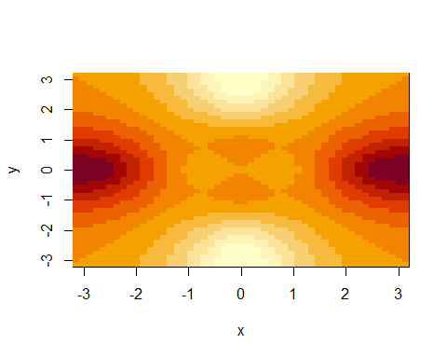

persp(x,y,fa)

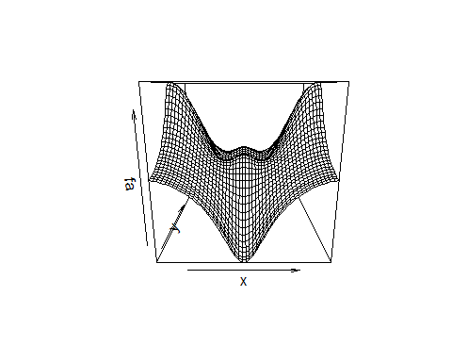

persp(x,y,fa,theta=30)

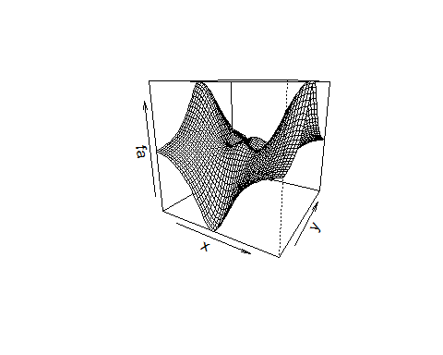

persp(x,y,fa,theta=30,phi=20)

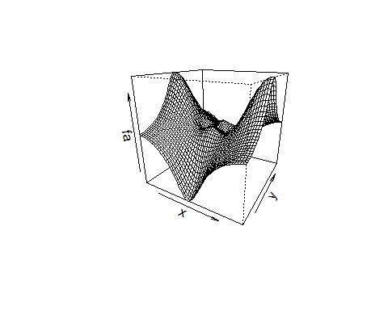

persp(x,y,fa,theta=30,phi=70)

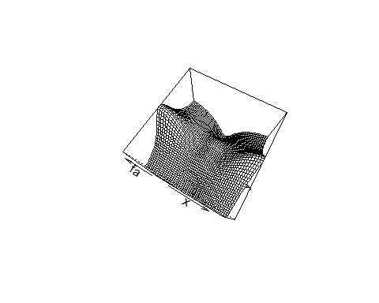

persp(x,y,fa,theta=30,phi=40)

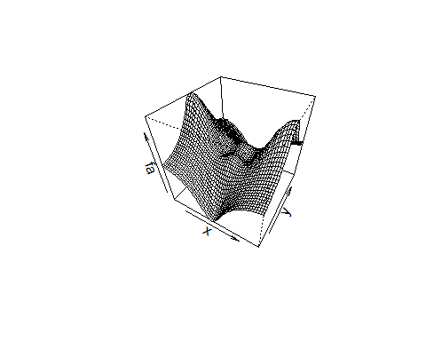

## 2.3.3 Indexing data

A <- matrix(1:16,4,4)  
A

## [,1] [,2] [,3] [,4]  
## [1,] 1 5 9 13  
## [2,] 2 6 10 14  
## [3,] 3 7 11 15  
## [4,] 4 8 12 16

A[2,3]

## [1] 10

A[c(1,3),c(2,4)]

## [,1] [,2]  
## [1,] 5 13  
## [2,] 7 15

A[1:3,2:4]

## [,1] [,2] [,3]  
## [1,] 5 9 13  
## [2,] 6 10 14  
## [3,] 7 11 15

A[1:2,]

## [,1] [,2] [,3] [,4]  
## [1,] 1 5 9 13  
## [2,] 2 6 10 14

A[,1:2]

## [,1] [,2]  
## [1,] 1 5  
## [2,] 2 6  
## [3,] 3 7  
## [4,] 4 8

A[-c(1,3),]

## [,1] [,2] [,3] [,4]  
## [1,] 2 6 10 14  
## [2,] 4 8 12 16

A[-c(1,3),-c(1,3,4)]

## [1] 6 8

dim(A)

## [1] 4 4

## 2.3.4 Loading data

# Auto <- read.table("Auto.data")  
# Auto <- read.csv("Auto.csv",header=T,na.strings="?")  
# Auto <- na.omit(Auto)  
# fix(Auto)  
# names(Auto)

## 2.3.5 Additional graphic and numerical summaries

plot(ISLR::Auto$cylinders,ISLR::Auto$mpg)

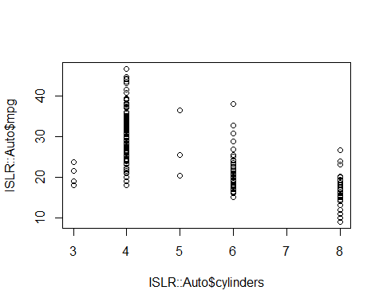

attach(ISLR::Auto)  
plot(cylinders,mpg)

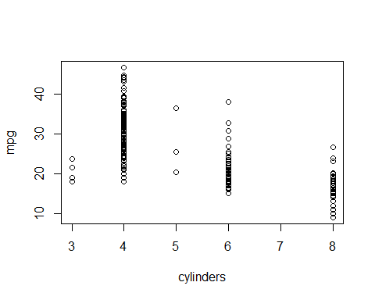

cylinders = as.factor(cylinders)  
plot(cylinders, mpg, col="red", varwidth=T, xlab="cylinders",ylab="MPG")

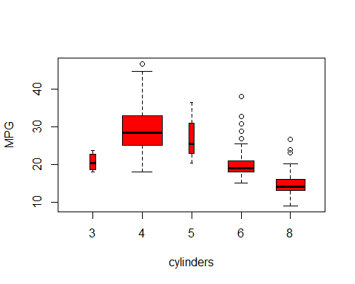

hist(mpg)

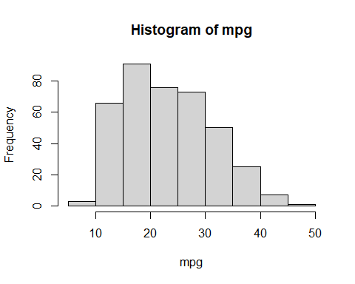

hist(mpg,col=2)

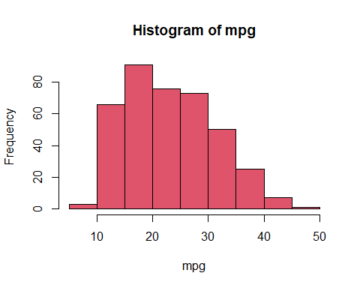

hist(mpg,col=2,breaks=15)

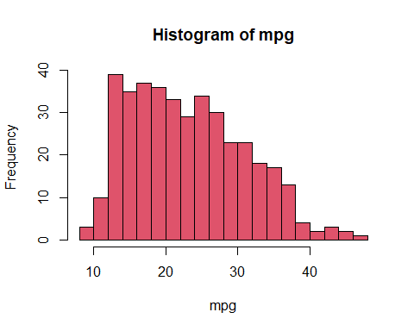

pairs(ISLR::Auto)

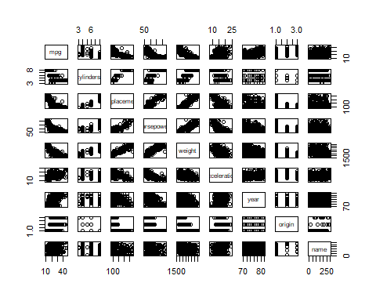

pairs(~mpg + displacement + horsepower + weight + acceleration, ISLR::Auto)

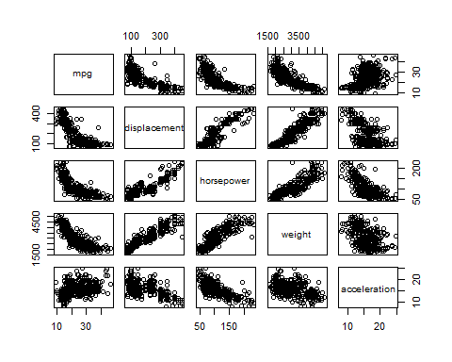

plot(horsepower,mpg)  
identify(horsepower, mpg, name)

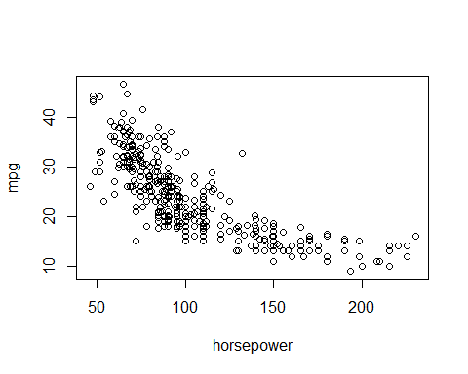

## integer(0)

summary(ISLR::Auto)

## mpg cylinders displacement horsepower weight   
## Min. : 9.00 Min. :3.000 Min. : 68.0 Min. : 46.0 Min. :1613   
## 1st Qu.:17.00 1st Qu.:4.000 1st Qu.:105.0 1st Qu.: 75.0 1st Qu.:2225   
## Median :22.75 Median :4.000 Median :151.0 Median : 93.5 Median :2804   
## Mean :23.45 Mean :5.472 Mean :194.4 Mean :104.5 Mean :2978   
## 3rd Qu.:29.00 3rd Qu.:8.000 3rd Qu.:275.8 3rd Qu.:126.0 3rd Qu.:3615   
## Max. :46.60 Max. :8.000 Max. :455.0 Max. :230.0 Max. :5140   
##   
## acceleration year origin name   
## Min. : 8.00 Min. :70.00 Min. :1.000 amc matador : 5   
## 1st Qu.:13.78 1st Qu.:73.00 1st Qu.:1.000 ford pinto : 5   
## Median :15.50 Median :76.00 Median :1.000 toyota corolla : 5   
## Mean :15.54 Mean :75.98 Mean :1.577 amc gremlin : 4   
## 3rd Qu.:17.02 3rd Qu.:79.00 3rd Qu.:2.000 amc hornet : 4   
## Max. :24.80 Max. :82.00 Max. :3.000 chevrolet chevette: 4   
## (Other) :365

summary(mpg)

## Min. 1st Qu. Median Mean 3rd Qu. Max.   
## 9.00 17.00 22.75 23.45 29.00 46.60

# 3.6 Linear Regression

## 3.6.1 Libraries

#install.packages("MASS")  
#install.packages("ISLR")  
library(MASS)

## Warning: package 'MASS' was built under R version 4.0.5

library(ISLR)

## Warning: package 'ISLR' was built under R version 4.0.5

## 3.6.2 Simple linear regression

names(Boston)

## [1] "crim" "zn" "indus" "chas" "nox" "rm" "age"   
## [8] "dis" "rad" "tax" "ptratio" "black" "lstat" "medv"

lm.fit <- lm(medv ~ lstat,data=Boston)  
lm.fit

##   
## Call:  
## lm(formula = medv ~ lstat, data = Boston)  
##   
## Coefficients:  
## (Intercept) lstat   
## 34.55 -0.95

summary(lm.fit)

##   
## Call:  
## lm(formula = medv ~ lstat, data = Boston)  
##   
## Residuals:  
## Min 1Q Median 3Q Max   
## -15.168 -3.990 -1.318 2.034 24.500   
##   
## Coefficients:  
## Estimate Std. Error t value Pr(>|t|)   
## (Intercept) 34.55384 0.56263 61.41 <2e-16 ***  
## lstat -0.95005 0.03873 -24.53 <2e-16 ***  
## ---  
## Signif. codes: 0 '***' 0.001 '**' 0.01 '*' 0.05 '.' 0.1 ' ' 1  
##   
## Residual standard error: 6.216 on 504 degrees of freedom  
## Multiple R-squared: 0.5441, Adjusted R-squared: 0.5432   
## F-statistic: 601.6 on 1 and 504 DF, p-value: < 2.2e-16

names(lm.fit)

## [1] "coefficients" "residuals" "effects" "rank"   
## [5] "fitted.values" "assign" "qr" "df.residual"   
## [9] "xlevels" "call" "terms" "model"

coef(lm.fit)

## (Intercept) lstat   
## 34.5538409 -0.9500494

confint(lm.fit)

## 2.5 % 97.5 %  
## (Intercept) 33.448457 35.6592247  
## lstat -1.026148 -0.8739505

predict(lm.fit,data.frame(lstat=(c(5,10,15))),interval="confidence")

## fit lwr upr  
## 1 29.80359 29.00741 30.59978  
## 2 25.05335 24.47413 25.63256  
## 3 20.30310 19.73159 20.87461

predict(lm.fit,data.frame(lstat=(c(5,10,15))),interval="prediction")

## fit lwr upr  
## 1 29.80359 17.565675 42.04151  
## 2 25.05335 12.827626 37.27907  
## 3 20.30310 8.077742 32.52846

par(mfrow=c(2,2))  
plot(lm.fit)

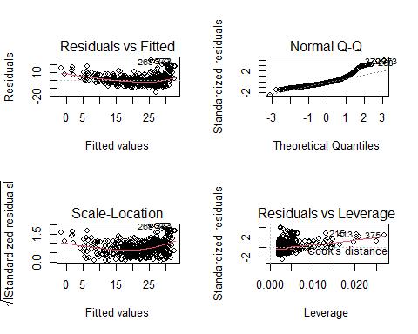

plot(predict(lm.fit),residuals(lm.fit))

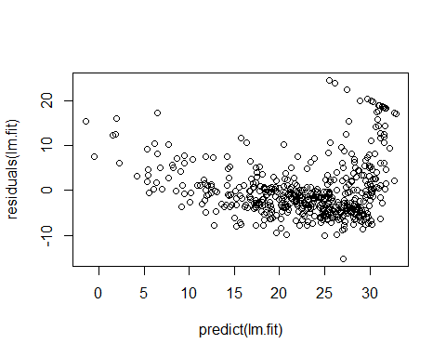

plot(predict(lm.fit),rstudent(lm.fit))

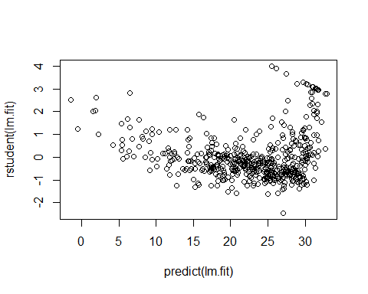

plot(hatvalues(lm.fit))

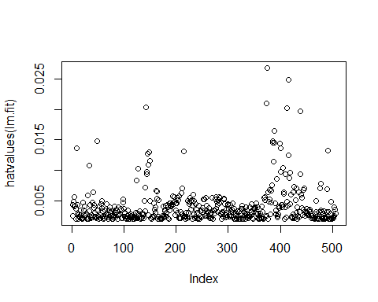

which.max(hatvalues(lm.fit))

## 375   
## 375

## 3.6.3 Multiple Linear Regression

library(MASS)  
library(ISLR)

lm.fit <- lm(medv~lstat+age,data=Boston) summary(lm.fit)

```r  
lm.fit <- lm(medv~.,data=Boston)  
summary(lm.fit)

##   
## Call:  
## lm(formula = medv ~ ., data = Boston)  
##   
## Residuals:  
## Min 1Q Median 3Q Max   
## -15.595 -2.730 -0.518 1.777 26.199   
##   
## Coefficients:  
## Estimate Std. Error t value Pr(>|t|)   
## (Intercept) 3.646e+01 5.103e+00 7.144 3.28e-12 ***  
## crim -1.080e-01 3.286e-02 -3.287 0.001087 **   
## zn 4.642e-02 1.373e-02 3.382 0.000778 ***  
## indus 2.056e-02 6.150e-02 0.334 0.738288   
## chas 2.687e+00 8.616e-01 3.118 0.001925 **   
## nox -1.777e+01 3.820e+00 -4.651 4.25e-06 ***  
## rm 3.810e+00 4.179e-01 9.116 < 2e-16 ***  
## age 6.922e-04 1.321e-02 0.052 0.958229   
## dis -1.476e+00 1.995e-01 -7.398 6.01e-13 ***  
## rad 3.060e-01 6.635e-02 4.613 5.07e-06 ***  
## tax -1.233e-02 3.760e-03 -3.280 0.001112 **   
## ptratio -9.527e-01 1.308e-01 -7.283 1.31e-12 ***  
## black 9.312e-03 2.686e-03 3.467 0.000573 ***  
## lstat -5.248e-01 5.072e-02 -10.347 < 2e-16 ***  
## ---  
## Signif. codes: 0 '***' 0.001 '**' 0.01 '*' 0.05 '.' 0.1 ' ' 1  
##   
## Residual standard error: 4.745 on 492 degrees of freedom  
## Multiple R-squared: 0.7406, Adjusted R-squared: 0.7338   
## F-statistic: 108.1 on 13 and 492 DF, p-value: < 2.2e-16

#install.packages("car")  
library(car)

## Warning: package 'car' was built under R version 4.0.5

## Loading required package: carData

## Warning: package 'carData' was built under R version 4.0.3

vif(lm.fit)

## crim zn indus chas nox rm age dis   
## 1.792192 2.298758 3.991596 1.073995 4.393720 1.933744 3.100826 3.955945   
## rad tax ptratio black lstat   
## 7.484496 9.008554 1.799084 1.348521 2.941491

lm.fit1 <- lm(medv~.-age,data=Boston)  
summary(lm.fit1)

##   
## Call:  
## lm(formula = medv ~ . - age, data = Boston)  
##   
## Residuals:  
## Min 1Q Median 3Q Max   
## -15.6054 -2.7313 -0.5188 1.7601 26.2243   
##   
## Coefficients:  
## Estimate Std. Error t value Pr(>|t|)   
## (Intercept) 36.436927 5.080119 7.172 2.72e-12 ***  
## crim -0.108006 0.032832 -3.290 0.001075 **   
## zn 0.046334 0.013613 3.404 0.000719 ***  
## indus 0.020562 0.061433 0.335 0.737989   
## chas 2.689026 0.859598 3.128 0.001863 **   
## nox -17.713540 3.679308 -4.814 1.97e-06 ***  
## rm 3.814394 0.408480 9.338 < 2e-16 ***  
## dis -1.478612 0.190611 -7.757 5.03e-14 ***  
## rad 0.305786 0.066089 4.627 4.75e-06 ***  
## tax -0.012329 0.003755 -3.283 0.001099 **   
## ptratio -0.952211 0.130294 -7.308 1.10e-12 ***  
## black 0.009321 0.002678 3.481 0.000544 ***  
## lstat -0.523852 0.047625 -10.999 < 2e-16 ***  
## ---  
## Signif. codes: 0 '***' 0.001 '**' 0.01 '*' 0.05 '.' 0.1 ' ' 1  
##   
## Residual standard error: 4.74 on 493 degrees of freedom  
## Multiple R-squared: 0.7406, Adjusted R-squared: 0.7343   
## F-statistic: 117.3 on 12 and 493 DF, p-value: < 2.2e-16

lm.fit1 <- update(lm.fit,~.-age)

## 3.6.4 Interaction Terms

summary(lm(medv~lstat*age,data=Boston))

##   
## Call:  
## lm(formula = medv ~ lstat * age, data = Boston)  
##   
## Residuals:  
## Min 1Q Median 3Q Max   
## -15.806 -4.045 -1.333 2.085 27.552   
##   
## Coefficients:  
## Estimate Std. Error t value Pr(>|t|)   
## (Intercept) 36.0885359 1.4698355 24.553 < 2e-16 ***  
## lstat -1.3921168 0.1674555 -8.313 8.78e-16 ***  
## age -0.0007209 0.0198792 -0.036 0.9711   
## lstat:age 0.0041560 0.0018518 2.244 0.0252 *   
## ---  
## Signif. codes: 0 '***' 0.001 '**' 0.01 '*' 0.05 '.' 0.1 ' ' 1  
##   
## Residual standard error: 6.149 on 502 degrees of freedom  
## Multiple R-squared: 0.5557, Adjusted R-squared: 0.5531   
## F-statistic: 209.3 on 3 and 502 DF, p-value: < 2.2e-16

## 3.6.5 Non-linear transformations of the predictors

lm.fit2 <- lm(medv~lstat+I(lstat^2),Boston)  
summary(lm.fit2)

##   
## Call:  
## lm(formula = medv ~ lstat + I(lstat^2), data = Boston)  
##   
## Residuals:  
## Min 1Q Median 3Q Max   
## -15.2834 -3.8313 -0.5295 2.3095 25.4148   
##   
## Coefficients:  
## Estimate Std. Error t value Pr(>|t|)   
## (Intercept) 42.862007 0.872084 49.15 <2e-16 ***  
## lstat -2.332821 0.123803 -18.84 <2e-16 ***  
## I(lstat^2) 0.043547 0.003745 11.63 <2e-16 ***  
## ---  
## Signif. codes: 0 '***' 0.001 '**' 0.01 '*' 0.05 '.' 0.1 ' ' 1  
##   
## Residual standard error: 5.524 on 503 degrees of freedom  
## Multiple R-squared: 0.6407, Adjusted R-squared: 0.6393   
## F-statistic: 448.5 on 2 and 503 DF, p-value: < 2.2e-16

lm.fit <- lm(medv ~ lstat,Boston)  
anova(lm.fit,lm.fit2)

## Analysis of Variance Table  
##   
## Model 1: medv ~ lstat  
## Model 2: medv ~ lstat + I(lstat^2)  
## Res.Df RSS Df Sum of Sq F Pr(>F)   
## 1 504 19472   
## 2 503 15347 1 4125.1 135.2 < 2.2e-16 ***  
## ---  
## Signif. codes: 0 '***' 0.001 '**' 0.01 '*' 0.05 '.' 0.1 ' ' 1

par(mfrow=c(2,2))  
plot(lm.fit2)

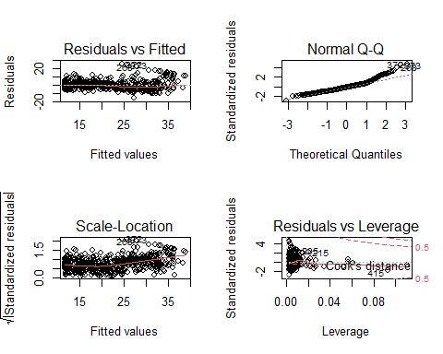

lm.fit5 <- lm(medv~poly(lstat,5),Boston)  
summary(lm.fit5)

##   
## Call:  
## lm(formula = medv ~ poly(lstat, 5), data = Boston)  
##   
## Residuals:  
## Min 1Q Median 3Q Max   
## -13.5433 -3.1039 -0.7052 2.0844 27.1153   
##   
## Coefficients:  
## Estimate Std. Error t value Pr(>|t|)   
## (Intercept) 22.5328 0.2318 97.197 < 2e-16 ***  
## poly(lstat, 5)1 -152.4595 5.2148 -29.236 < 2e-16 ***  
## poly(lstat, 5)2 64.2272 5.2148 12.316 < 2e-16 ***  
## poly(lstat, 5)3 -27.0511 5.2148 -5.187 3.10e-07 ***  
## poly(lstat, 5)4 25.4517 5.2148 4.881 1.42e-06 ***  
## poly(lstat, 5)5 -19.2524 5.2148 -3.692 0.000247 ***  
## ---  
## Signif. codes: 0 '***' 0.001 '**' 0.01 '*' 0.05 '.' 0.1 ' ' 1  
##   
## Residual standard error: 5.215 on 500 degrees of freedom  
## Multiple R-squared: 0.6817, Adjusted R-squared: 0.6785   
## F-statistic: 214.2 on 5 and 500 DF, p-value: < 2.2e-16

summary(lm(medv~log(rm),data=Boston))

##   
## Call:  
## lm(formula = medv ~ log(rm), data = Boston)  
##   
## Residuals:  
## Min 1Q Median 3Q Max   
## -19.487 -2.875 -0.104 2.837 39.816   
##   
## Coefficients:  
## Estimate Std. Error t value Pr(>|t|)   
## (Intercept) -76.488 5.028 -15.21 <2e-16 ***  
## log(rm) 54.055 2.739 19.73 <2e-16 ***  
## ---  
## Signif. codes: 0 '***' 0.001 '**' 0.01 '*' 0.05 '.' 0.1 ' ' 1  
##   
## Residual standard error: 6.915 on 504 degrees of freedom  
## Multiple R-squared: 0.4358, Adjusted R-squared: 0.4347   
## F-statistic: 389.3 on 1 and 504 DF, p-value: < 2.2e-16

## 3.6.6 Qualitative predictors

names(Carseats)

## [1] "Sales" "CompPrice" "Income" "Advertising" "Population"   
## [6] "Price" "ShelveLoc" "Age" "Education" "Urban"   
## [11] "US"

lm.fit <- lm(Sales~.+Income:Advertising+Price:Age,Carseats)  
summary(lm.fit)

##   
## Call:  
## lm(formula = Sales ~ . + Income:Advertising + Price:Age, data = Carseats)  
##   
## Residuals:  
## Min 1Q Median 3Q Max   
## -2.9208 -0.7503 0.0177 0.6754 3.3413   
##   
## Coefficients:  
## Estimate Std. Error t value Pr(>|t|)   
## (Intercept) 6.5755654 1.0087470 6.519 2.22e-10 ***  
## CompPrice 0.0929371 0.0041183 22.567 < 2e-16 ***  
## Income 0.0108940 0.0026044 4.183 3.57e-05 ***  
## Advertising 0.0702462 0.0226091 3.107 0.002030 **   
## Population 0.0001592 0.0003679 0.433 0.665330   
## Price -0.1008064 0.0074399 -13.549 < 2e-16 ***  
## ShelveLocGood 4.8486762 0.1528378 31.724 < 2e-16 ***  
## ShelveLocMedium 1.9532620 0.1257682 15.531 < 2e-16 ***  
## Age -0.0579466 0.0159506 -3.633 0.000318 ***  
## Education -0.0208525 0.0196131 -1.063 0.288361   
## UrbanYes 0.1401597 0.1124019 1.247 0.213171   
## USYes -0.1575571 0.1489234 -1.058 0.290729   
## Income:Advertising 0.0007510 0.0002784 2.698 0.007290 **   
## Price:Age 0.0001068 0.0001333 0.801 0.423812   
## ---  
## Signif. codes: 0 '***' 0.001 '**' 0.01 '*' 0.05 '.' 0.1 ' ' 1  
##   
## Residual standard error: 1.011 on 386 degrees of freedom  
## Multiple R-squared: 0.8761, Adjusted R-squared: 0.8719   
## F-statistic: 210 on 13 and 386 DF, p-value: < 2.2e-16

attach(Carseats)  
contrasts(ShelveLoc)

## Good Medium  
## Bad 0 0  
## Good 1 0  
## Medium 0 1

## 3.6.7 Writing functions

LoadLibaries <- function() {  
 library(ISLR)  
 library(MASS)  
 print("The libraries have been loaded.")  
}  
LoadLibaries()

## [1] "The libraries have been loaded."

# 4.6 Logistic Regression, LDA, QDA, and KNN

## 4.6.1 The stock market data

library(ISLR)  
names(Smarket)

## [1] "Year" "Lag1" "Lag2" "Lag3" "Lag4" "Lag5"   
## [7] "Volume" "Today" "Direction"

dim(Smarket)

## [1] 1250 9

summary(Smarket)

## Year Lag1 Lag2 Lag3   
## Min. :2001 Min. :-4.922000 Min. :-4.922000 Min. :-4.922000   
## 1st Qu.:2002 1st Qu.:-0.639500 1st Qu.:-0.639500 1st Qu.:-0.640000   
## Median :2003 Median : 0.039000 Median : 0.039000 Median : 0.038500   
## Mean :2003 Mean : 0.003834 Mean : 0.003919 Mean : 0.001716   
## 3rd Qu.:2004 3rd Qu.: 0.596750 3rd Qu.: 0.596750 3rd Qu.: 0.596750   
## Max. :2005 Max. : 5.733000 Max. : 5.733000 Max. : 5.733000   
## Lag4 Lag5 Volume Today   
## Min. :-4.922000 Min. :-4.92200 Min. :0.3561 Min. :-4.922000   
## 1st Qu.:-0.640000 1st Qu.:-0.64000 1st Qu.:1.2574 1st Qu.:-0.639500   
## Median : 0.038500 Median : 0.03850 Median :1.4229 Median : 0.038500   
## Mean : 0.001636 Mean : 0.00561 Mean :1.4783 Mean : 0.003138   
## 3rd Qu.: 0.596750 3rd Qu.: 0.59700 3rd Qu.:1.6417 3rd Qu.: 0.596750   
## Max. : 5.733000 Max. : 5.73300 Max. :3.1525 Max. : 5.733000   
## Direction   
## Down:602   
## Up :648   
##   
##   
##   
##

cor(Smarket[,-9])

## Year Lag1 Lag2 Lag3 Lag4  
## Year 1.00000000 0.029699649 0.030596422 0.033194581 0.035688718  
## Lag1 0.02969965 1.000000000 -0.026294328 -0.010803402 -0.002985911  
## Lag2 0.03059642 -0.026294328 1.000000000 -0.025896670 -0.010853533  
## Lag3 0.03319458 -0.010803402 -0.025896670 1.000000000 -0.024051036  
## Lag4 0.03568872 -0.002985911 -0.010853533 -0.024051036 1.000000000  
## Lag5 0.02978799 -0.005674606 -0.003557949 -0.018808338 -0.027083641  
## Volume 0.53900647 0.040909908 -0.043383215 -0.041823686 -0.048414246  
## Today 0.03009523 -0.026155045 -0.010250033 -0.002447647 -0.006899527  
## Lag5 Volume Today  
## Year 0.029787995 0.53900647 0.030095229  
## Lag1 -0.005674606 0.04090991 -0.026155045  
## Lag2 -0.003557949 -0.04338321 -0.010250033  
## Lag3 -0.018808338 -0.04182369 -0.002447647  
## Lag4 -0.027083641 -0.04841425 -0.006899527  
## Lag5 1.000000000 -0.02200231 -0.034860083  
## Volume -0.022002315 1.00000000 0.014591823  
## Today -0.034860083 0.01459182 1.000000000

attach(Smarket)  
plot(Volume)

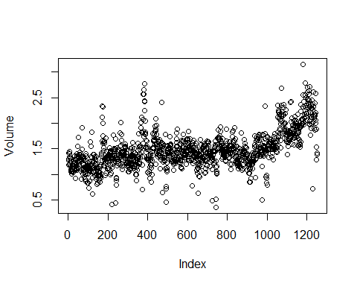

## 4.6.2 Logistic regression

glm.fit <- glm(Direction~Lag1 + Lag2 + Lag3 + Lag4 + Lag5 + Volume, data=Smarket, family=binomial)  
summary(glm.fit)

##   
## Call:  
## glm(formula = Direction ~ Lag1 + Lag2 + Lag3 + Lag4 + Lag5 +   
## Volume, family = binomial, data = Smarket)  
##   
## Deviance Residuals:   
## Min 1Q Median 3Q Max   
## -1.446 -1.203 1.065 1.145 1.326   
##   
## Coefficients:  
## Estimate Std. Error z value Pr(>|z|)  
## (Intercept) -0.126000 0.240736 -0.523 0.601  
## Lag1 -0.073074 0.050167 -1.457 0.145  
## Lag2 -0.042301 0.050086 -0.845 0.398  
## Lag3 0.011085 0.049939 0.222 0.824  
## Lag4 0.009359 0.049974 0.187 0.851  
## Lag5 0.010313 0.049511 0.208 0.835  
## Volume 0.135441 0.158360 0.855 0.392  
##   
## (Dispersion parameter for binomial family taken to be 1)  
##   
## Null deviance: 1731.2 on 1249 degrees of freedom  
## Residual deviance: 1727.6 on 1243 degrees of freedom  
## AIC: 1741.6  
##   
## Number of Fisher Scoring iterations: 3

coef(glm.fit)

## (Intercept) Lag1 Lag2 Lag3 Lag4 Lag5   
## -0.126000257 -0.073073746 -0.042301344 0.011085108 0.009358938 0.010313068   
## Volume   
## 0.135440659

summary(glm.fit)$coef

## Estimate Std. Error z value Pr(>|z|)  
## (Intercept) -0.126000257 0.24073574 -0.5233966 0.6006983  
## Lag1 -0.073073746 0.05016739 -1.4565986 0.1452272  
## Lag2 -0.042301344 0.05008605 -0.8445733 0.3983491  
## Lag3 0.011085108 0.04993854 0.2219750 0.8243333  
## Lag4 0.009358938 0.04997413 0.1872757 0.8514445  
## Lag5 0.010313068 0.04951146 0.2082966 0.8349974  
## Volume 0.135440659 0.15835970 0.8552723 0.3924004

glm.probs <- predict(glm.fit, type="response")  
glm.probs[1:10]

## 1 2 3 4 5 6 7 8   
## 0.5070841 0.4814679 0.4811388 0.5152224 0.5107812 0.5069565 0.4926509 0.5092292   
## 9 10   
## 0.5176135 0.4888378

contrasts(Direction)

## Up  
## Down 0  
## Up 1

glm.pred <- rep("Down",1250)  
glm.pred[glm.probs>0.5]="Up"  
table(glm.pred,Direction)

## Direction  
## glm.pred Down Up  
## Down 145 141  
## Up 457 507

mean(glm.pred==Direction)

## [1] 0.5216

train <- (Year<2005)  
Smarket.2005 <- Smarket[!train,]  
dim(Smarket.2005)

## [1] 252 9

Direction.2005 <- Direction[!train]

glm.fit <- glm(Direction~Lag1+Lag2+Lag3+Lag4+Lag5+Volume,data=Smarket,family=binomial,subset=train)  
glm.probs <- predict(glm.fit,Smarket,subset=train)

glm.pred <- rep("Down",252)  
glm.pred[glm.probs>0.5]="Up"  
# table(glm.pred,Direction.2005)  
mean(glm.pred==Direction.2005)

## Warning in `==.default`(glm.pred, Direction.2005): longer object length is not a  
## multiple of shorter object length

## Warning in is.na(e1) | is.na(e2): longer object length is not a multiple of  
## shorter object length

## [1] NA

mean(glm.pred!=Direction.2005)

## Warning in `!=.default`(glm.pred, Direction.2005): longer object length is not a  
## multiple of shorter object length  
  
## Warning in `!=.default`(glm.pred, Direction.2005): longer object length is not a  
## multiple of shorter object length

## [1] NA

glm.fit <- glm(Direction~Lag1+Lag2,data=Smarket,family=binomial,subset=train)  
glm.probs <- predict(glm.fit,Smarket.2005,type="response")  
glm.pred <- rep("Down",252)  
glm.pred[glm.probs>0.5]="Up"  
table(glm.pred,Direction.2005)

## Direction.2005  
## glm.pred Down Up  
## Down 35 35  
## Up 76 106

mean(glm.pred==Direction.2005)

## [1] 0.5595238

predict(glm.fit, newdata=data.frame(Lag1=c(1.2,1.5),Lag2=c(1.1,-0.8)),type="response")

## 1 2   
## 0.4791462 0.4960939

## 4.6.3 Linear Discriminant Analysis

library(MASS)  
lda.fit <- lda(Direction~Lag1 + Lag2, data=Smarket,subset=train)  
lda.fit

## Call:  
## lda(Direction ~ Lag1 + Lag2, data = Smarket, subset = train)  
##   
## Prior probabilities of groups:  
## Down Up   
## 0.491984 0.508016   
##   
## Group means:  
## Lag1 Lag2  
## Down 0.04279022 0.03389409  
## Up -0.03954635 -0.03132544  
##   
## Coefficients of linear discriminants:  
## LD1  
## Lag1 -0.6420190  
## Lag2 -0.5135293

plot(lda.fit)

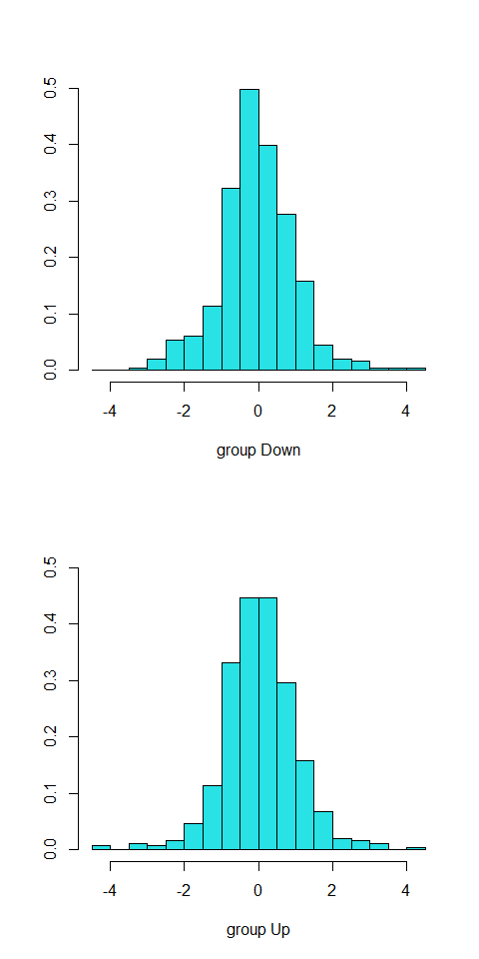

lda.pred <- predict(lda.fit,Smarket.2005)  
names(lda.pred)

## [1] "class" "posterior" "x"

lda.class <- lda.pred$class  
table(lda.class,Direction.2005)

## Direction.2005  
## lda.class Down Up  
## Down 35 35  
## Up 76 106

mean(lda.class==Direction.2005)

## [1] 0.5595238

sum(lda.pred$posterior[,1]>=0.5)

## [1] 70

sum(lda.pred$posterior[,1]<=0.5)

## [1] 182

lda.pred$posterior[1:20,1]

## 999 1000 1001 1002 1003 1004 1005 1006   
## 0.4901792 0.4792185 0.4668185 0.4740011 0.4927877 0.4938562 0.4951016 0.4872861   
## 1007 1008 1009 1010 1011 1012 1013 1014   
## 0.4907013 0.4844026 0.4906963 0.5119988 0.4895152 0.4706761 0.4744593 0.4799583   
## 1015 1016 1017 1018   
## 0.4935775 0.5030894 0.4978806 0.4886331

lda.class[1:20]

## [1] Up Up Up Up Up Up Up Up Up Up Up Down Up Up Up   
## [16] Up Up Down Up Up   
## Levels: Down Up

sum(lda.pred$posterior[,1]>0.9)

## [1] 0

## 4.6.4 Quadratic discriminant analysis

qda.fit <- qda(Direction~Lag1+Lag2,data=Smarket,subset=train)  
qda.fit

## Call:  
## qda(Direction ~ Lag1 + Lag2, data = Smarket, subset = train)  
##   
## Prior probabilities of groups:  
## Down Up   
## 0.491984 0.508016   
##   
## Group means:  
## Lag1 Lag2  
## Down 0.04279022 0.03389409  
## Up -0.03954635 -0.03132544

qda.class <- predict(qda.fit,Smarket.2005)$class  
table(qda.class,Direction.2005)

## Direction.2005  
## qda.class Down Up  
## Down 30 20  
## Up 81 121

mean(qda.class==Direction.2005)

## [1] 0.5992063

## 4.6.5 K-nearest neighbors

#install.packages("class")  
library(class)

## Warning: package 'class' was built under R version 4.0.5

train.X <- cbind(Lag1,Lag2)[train,]  
test.X <- cbind(Lag1,Lag2)[!train,]  
train.Direction <- Direction[train]

set.seed(1)  
knn.pred <- knn(train.X,test.X,train.Direction,k=1)  
table(knn.pred,Direction.2005)

## Direction.2005  
## knn.pred Down Up  
## Down 43 58  
## Up 68 83

mean(knn.pred==Direction.2005)

## [1] 0.5

knn.pred <- knn(train.X,test.X,train.Direction,k=3)  
table(knn.pred,Direction.2005)

## Direction.2005  
## knn.pred Down Up  
## Down 48 54  
## Up 63 87

mean(knn.pred==Direction.2005)

## [1] 0.5357143

## 4.6.6 An application to caravan insurance data

dim(Caravan)

## [1] 5822 86

attach(Caravan)  
summary(Purchase)

## No Yes   
## 5474 348

348/5822

## [1] 0.05977327

standardized.X <- scale(Caravan[,-86])  
var(Caravan[,1])

## [1] 165.0378

var(Caravan[,2])

## [1] 0.1647078

var(standardized.X[,1])

## [1] 1

var(standardized.X[,2])

## [1] 1

test <- 1:1000  
train.X <- standardized.X[-test,]  
test.X <- standardized.X[test,]  
train.Y <- Purchase[-test]  
test.Y <- Purchase[test]  
set.seed(1)  
knn.pred <- knn(train.X,test.X,train.Y,k=1)  
mean(test.Y!=knn.pred)

## [1] 0.118

mean(test.Y!="No")

## [1] 0.059

table(knn.pred,test.Y)

## test.Y  
## knn.pred No Yes  
## No 873 50  
## Yes 68 9

9/(68+9)

## [1] 0.1168831

knn.pred <- knn(train.X,test.X,train.Y,k=3)  
table(knn.pred,test.Y)

## test.Y  
## knn.pred No Yes  
## No 920 54  
## Yes 21 5

5/26

## [1] 0.1923077

knn.pred <- knn(train.X,test.X,train.Y,k=5)  
table(knn.pred,test.Y)

## test.Y  
## knn.pred No Yes  
## No 930 55  
## Yes 11 4

4/15

## [1] 0.2666667

glm.fit <- glm(Purchase~.,data=Caravan,family=binomial,subset=-test)

## Warning: glm.fit: fitted probabilities numerically 0 or 1 occurred

glm.probs <- predict(glm.fit,Caravan[test,],type="response")  
glm.pred <- rep("No",1000)  
glm.pred[glm.probs>0.5]<-"Yes"  
table(glm.pred,test.Y)

## test.Y  
## glm.pred No Yes  
## No 934 59  
## Yes 7 0

glm.pred <- rep("No",1000)  
glm.pred[glm.probs>0.25]<-"Yes"  
table(glm.pred,test.Y)

## test.Y  
## glm.pred No Yes  
## No 919 48  
## Yes 22 11

11/(22+11)

## [1] 0.3333333

# 5.3 Cross-Validation and the Bootstrap

## 5.3.1 The validation set approach

library(ISLR)  
set.seed(1)  
train <- sample(392,196)

lm.fit <- lm(mpg~horsepower,data=ISLR::Auto,subset=train)

attach(ISLR::Auto)

## The following object is masked _by_ .GlobalEnv:  
##   
## cylinders

## The following objects are masked from ISLR::Auto (pos = 11):  
##   
## acceleration, cylinders, displacement, horsepower, mpg, name,  
## origin, weight, year

mean((mpg-predict(lm.fit,ISLR::Auto))[-train]^2)

## [1] 23.26601

lm.fit2 <- lm(mpg~poly(horsepower,2),data=ISLR::Auto,subset=train)  
mean((mpg-predict(lm.fit2,ISLR::Auto))[-train]^2)

## [1] 18.71646

lm.fit3 <- lm(mpg~poly(horsepower,3),data=ISLR::Auto,subset=train)  
mean((mpg-predict(lm.fit3,ISLR::Auto))[-train]^2)

## [1] 18.79401

set.seed(2)  
train=sample(392,196)  
lm.fit <- lm(mpg~horsepower,subset=train)  
mean((mpg-predict(lm.fit,ISLR::Auto))[-train]^2)

## [1] 25.72651

lm.fit2 <- lm(mpg~poly(horsepower,2),data=ISLR::Auto,subset=train)  
mean((mpg-predict(lm.fit2,ISLR::Auto))[-train]^2)

## [1] 20.43036

lm.fit3 <- lm(mpg~poly(horsepower,3),data=ISLR::Auto,subset=train)  
mean((mpg-predict(lm.fit3,ISLR::Auto))[-train]^2)

## [1] 20.38533

## 5.3.2 Leave one out cross validation

glm.fit <- glm(mpg~horsepower,data=ISLR::Auto)  
coef(glm.fit)

## (Intercept) horsepower   
## 39.9358610 -0.1578447

lm.fit <- lm(mpg~horsepower,data=ISLR::Auto)  
coef(lm.fit)

## (Intercept) horsepower   
## 39.9358610 -0.1578447

#install.packages("boot")  
library(boot)

## Warning: package 'boot' was built under R version 4.0.5

##   
## Attaching package: 'boot'

## The following object is masked from 'package:car':  
##   
## logit

glm.fit <- glm(mpg~horsepower,data=ISLR::Auto)  
cv.err <- cv.glm(ISLR::Auto,glm.fit)  
cv.err$delta

## [1] 24.23151 24.23114

names(cv.err)

## [1] "call" "K" "delta" "seed"

cv.error <- rep(0,5)  
for(i in 1:5){  
 glm.fit <- glm(mpg~poly(horsepower,i),data=ISLR::Auto)  
 cv.error[i] <- cv.glm(ISLR::Auto,glm.fit)$delta[1]  
}  
cv.error

## [1] 24.23151 19.24821 19.33498 19.42443 19.03321

plot(cv.error)

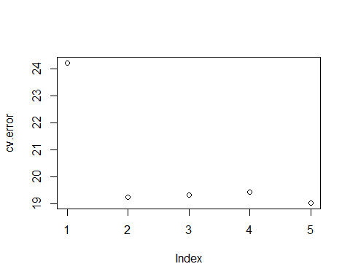

## 5.3.3 k-fold cross validation

set.seed(17)  
cv.error.10 <- rep(0,10)  
for(i in 1:10){  
 glm.fit <- glm(mpg~poly(horsepower,i),data=ISLR::Auto)  
 cv.error.10[i] <- cv.glm(ISLR::Auto,glm.fit,K=10)$delta[1]  
}  
cv.error.10

## [1] 24.27207 19.26909 19.34805 19.29496 19.03198 18.89781 19.12061 19.14666  
## [9] 18.87013 20.95520

plot(cv.error)



## 5.3.4 The bootstrap

alpha.fn <- function(data,index){  
 X <- data$X[index]  
 Y <- data$Y[index]  
 return((var(Y)-cov(X,Y))/(var(X)+var(Y)-2*cov(X,Y)))  
}

alpha.fn(Portfolio,1:100)

## [1] 0.5758321

set.seed(1)  
alpha.fn(Portfolio,sample(100,100,replace=T))

## [1] 0.7368375

boot(Portfolio,alpha.fn,R=1000)

##   
## ORDINARY NONPARAMETRIC BOOTSTRAP  
##   
##   
## Call:  
## boot(data = Portfolio, statistic = alpha.fn, R = 1000)  
##   
##   
## Bootstrap Statistics :  
## original bias std. error  
## t1* 0.5758321 -0.001695873 0.09366347

## Estimating the accuracy of a linear regression model

The bootstrap approach can be used to assess the variability of the coefficient estimates and predictions from a statistical learning method

boot.fn <- function(data,index) {  
 return(coef(lm(mpg~horsepower,data=data,subset=index)))  
}  
boot.fn(ISLR::Auto,1:392)

## (Intercept) horsepower   
## 39.9358610 -0.1578447

set.seed(1)  
boot.fn(ISLR::Auto,sample(392,392,replace=T))

## (Intercept) horsepower   
## 40.3404517 -0.1634868

boot.fn(ISLR::Auto,sample(392,392,replace=T))

## (Intercept) horsepower   
## 40.1186906 -0.1577063

boot(ISLR::Auto,boot.fn,1000)

##   
## ORDINARY NONPARAMETRIC BOOTSTRAP  
##   
##   
## Call:  
## boot(data = ISLR::Auto, statistic = boot.fn, R = 1000)  
##   
##   
## Bootstrap Statistics :  
## original bias std. error  
## t1* 39.9358610 0.0544513229 0.841289790  
## t2* -0.1578447 -0.0006170901 0.007343073

summary(lm(mpg~horsepower,data=ISLR::Auto))$coef

## Estimate Std. Error t value Pr(>|t|)  
## (Intercept) 39.9358610 0.717498656 55.65984 1.220362e-187  
## horsepower -0.1578447 0.006445501 -24.48914 7.031989e-81

boot.fn <- function(data,index){  
 coefficients(lm(mpg~horsepower+I(horsepower^2),data=data,subset=index))  
}  
set.seed(1)  
boot(ISLR::Auto,boot.fn,1000)

##   
## ORDINARY NONPARAMETRIC BOOTSTRAP  
##   
##   
## Call:  
## boot(data = ISLR::Auto, statistic = boot.fn, R = 1000)  
##   
##   
## Bootstrap Statistics :  
## original bias std. error  
## t1* 56.900099702 3.511640e-02 2.0300222526  
## t2* -0.466189630 -7.080834e-04 0.0324241984  
## t3* 0.001230536 2.840324e-06 0.0001172164

summary(lm(mpg~horsepower+I(horsepower^2),data=ISLR::Auto))$coef

## Estimate Std. Error t value Pr(>|t|)  
## (Intercept) 56.900099702 1.8004268063 31.60367 1.740911e-109  
## horsepower -0.466189630 0.0311246171 -14.97816 2.289429e-40  
## I(horsepower^2) 0.001230536 0.0001220759 10.08009 2.196340e-21

# 6.5 Lab1: Subset Selection Methods

## 6.5.1 Best subset selection

library(ISLR)  
names(Hitters)

## [1] "AtBat" "Hits" "HmRun" "Runs" "RBI" "Walks"   
## [7] "Years" "CAtBat" "CHits" "CHmRun" "CRuns" "CRBI"   
## [13] "CWalks" "League" "Division" "PutOuts" "Assists" "Errors"   
## [19] "Salary" "NewLeague"

dim(Hitters)

## [1] 322 20

sum(is.na(Hitters$Salary))

## [1] 59

Hitters <- na.omit(Hitters)  
dim(Hitters)

## [1] 263 20

sum(is.na(Hitters))

## [1] 0

#install.packages("leaps")  
library(leaps)

## Warning: package 'leaps' was built under R version 4.0.5

regfit.full <- regsubsets(Salary~.,Hitters)  
summary(regfit.full)

## Subset selection object  
## Call: regsubsets.formula(Salary ~ ., Hitters)  
## 19 Variables (and intercept)  
## Forced in Forced out  
## AtBat FALSE FALSE  
## Hits FALSE FALSE  
## HmRun FALSE FALSE  
## Runs FALSE FALSE  
## RBI FALSE FALSE  
## Walks FALSE FALSE  
## Years FALSE FALSE  
## CAtBat FALSE FALSE  
## CHits FALSE FALSE  
## CHmRun FALSE FALSE  
## CRuns FALSE FALSE  
## CRBI FALSE FALSE  
## CWalks FALSE FALSE  
## LeagueN FALSE FALSE  
## DivisionW FALSE FALSE  
## PutOuts FALSE FALSE  
## Assists FALSE FALSE  
## Errors FALSE FALSE  
## NewLeagueN FALSE FALSE  
## 1 subsets of each size up to 8  
## Selection Algorithm: exhaustive  
## AtBat Hits HmRun Runs RBI Walks Years CAtBat CHits CHmRun CRuns CRBI  
## 1 ( 1 ) " " " " " " " " " " " " " " " " " " " " " " "*"   
## 2 ( 1 ) " " "*" " " " " " " " " " " " " " " " " " " "*"   
## 3 ( 1 ) " " "*" " " " " " " " " " " " " " " " " " " "*"   
## 4 ( 1 ) " " "*" " " " " " " " " " " " " " " " " " " "*"   
## 5 ( 1 ) "*" "*" " " " " " " " " " " " " " " " " " " "*"   
## 6 ( 1 ) "*" "*" " " " " " " "*" " " " " " " " " " " "*"   
## 7 ( 1 ) " " "*" " " " " " " "*" " " "*" "*" "*" " " " "   
## 8 ( 1 ) "*" "*" " " " " " " "*" " " " " " " "*" "*" " "   
## CWalks LeagueN DivisionW PutOuts Assists Errors NewLeagueN  
## 1 ( 1 ) " " " " " " " " " " " " " "   
## 2 ( 1 ) " " " " " " " " " " " " " "   
## 3 ( 1 ) " " " " " " "*" " " " " " "   
## 4 ( 1 ) " " " " "*" "*" " " " " " "   
## 5 ( 1 ) " " " " "*" "*" " " " " " "   
## 6 ( 1 ) " " " " "*" "*" " " " " " "   
## 7 ( 1 ) " " " " "*" "*" " " " " " "   
## 8 ( 1 ) "*" " " "*" "*" " " " " " "

regfit.full <- regsubsets(Salary~.,data=Hitters,nvmax=19)  
reg.summary <- summary(regfit.full)  
names(reg.summary)

## [1] "which" "rsq" "rss" "adjr2" "cp" "bic" "outmat" "obj"

reg.summary$rsq

## [1] 0.3214501 0.4252237 0.4514294 0.4754067 0.4908036 0.5087146 0.5141227  
## [8] 0.5285569 0.5346124 0.5404950 0.5426153 0.5436302 0.5444570 0.5452164  
## [15] 0.5454692 0.5457656 0.5459518 0.5460945 0.5461159

par(mfrow=c(2,2))  
plot(reg.summary$rss,xlab="Number of variables",ylab="RSS",type="l")  
plot(reg.summary$adjr2,xlab="Number of variables",ylab="Adjusted Rsq",type="l")  
points(11,reg.summary$adjr2[11],col="red",pch=20)

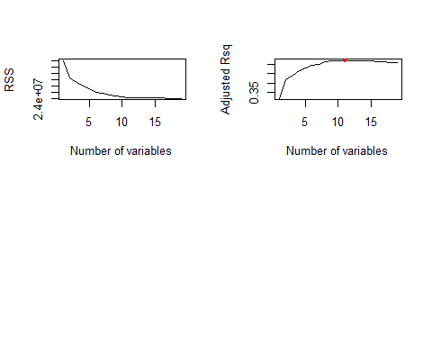

which.max(reg.summary$adjr2)

## [1] 11

plot(reg.summary$cp,xlab="Number of variables",ylab="Cp",type="l")  
which.min(reg.summary$cp)

## [1] 10

points(10,reg.summary$cp[10],col="red",cex=2,pch=20)

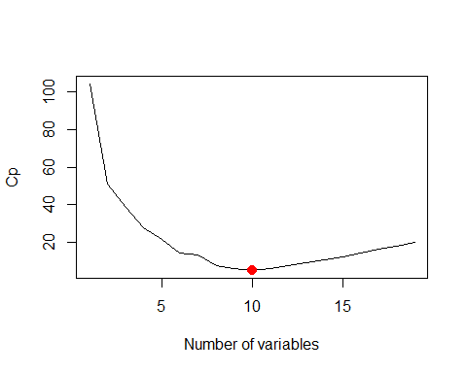

which.min(reg.summary$bic)

## [1] 6

plot(reg.summary$bic,xlab="Number of variables",ylab="BIC",type="l")  
points(6,reg.summary$bic[6],col="red",cex=2,pch=20)

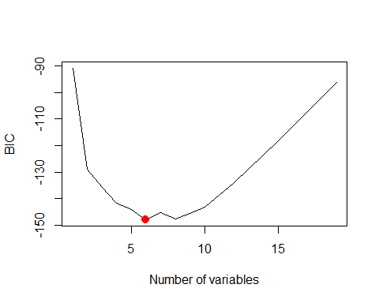

plot(regfit.full,scale="r2")

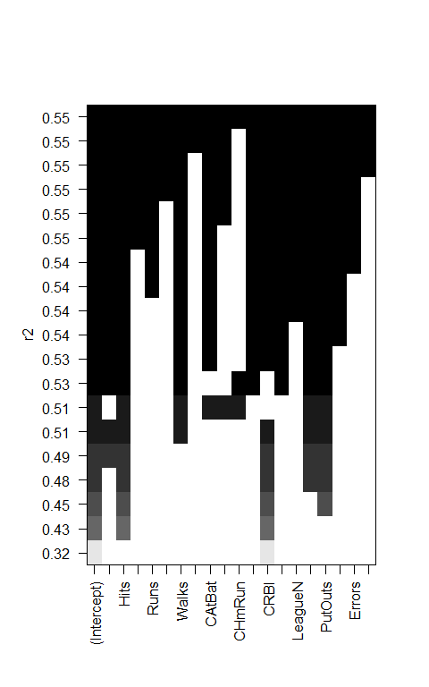

plot(regfit.full,scale="adjr2")

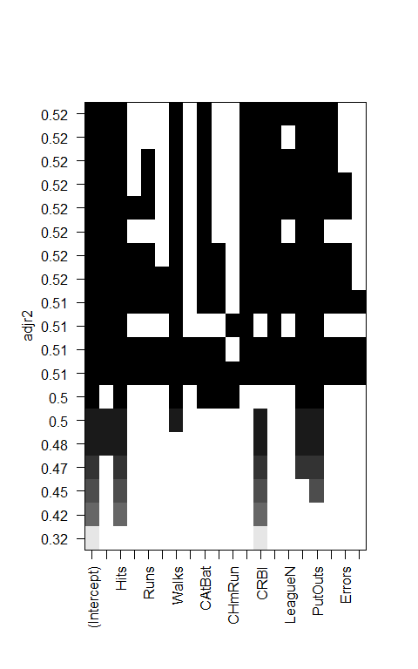

plot(regfit.full,scale="Cp")

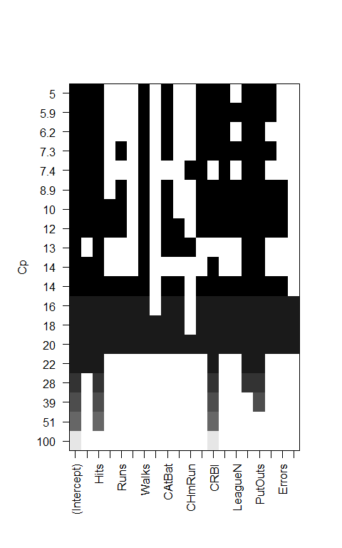

plot(regfit.full,scale="bic")

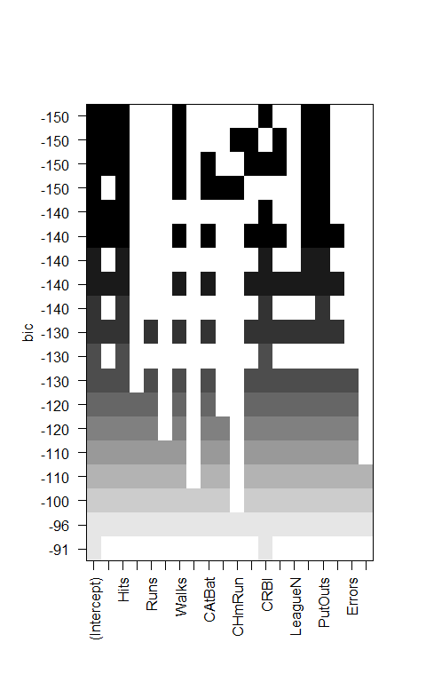

## 6.5.2 Forward and backward stepwise selection

regfit.fwd <- regsubsets(Salary~.,data=Hitters,nvmax=19,method="forward")  
summary(regfit.fwd)

## Subset selection object  
## Call: regsubsets.formula(Salary ~ ., data = Hitters, nvmax = 19, method = "forward")  
## 19 Variables (and intercept)  
## Forced in Forced out  
## AtBat FALSE FALSE  
## Hits FALSE FALSE  
## HmRun FALSE FALSE  
## Runs FALSE FALSE  
## RBI FALSE FALSE  
## Walks FALSE FALSE  
## Years FALSE FALSE  
## CAtBat FALSE FALSE  
## CHits FALSE FALSE  
## CHmRun FALSE FALSE  
## CRuns FALSE FALSE  
## CRBI FALSE FALSE  
## CWalks FALSE FALSE  
## LeagueN FALSE FALSE  
## DivisionW FALSE FALSE  
## PutOuts FALSE FALSE  
## Assists FALSE FALSE  
## Errors FALSE FALSE  
## NewLeagueN FALSE FALSE  
## 1 subsets of each size up to 19  
## Selection Algorithm: forward  
## AtBat Hits HmRun Runs RBI Walks Years CAtBat CHits CHmRun CRuns CRBI  
## 1 ( 1 ) " " " " " " " " " " " " " " " " " " " " " " "*"   
## 2 ( 1 ) " " "*" " " " " " " " " " " " " " " " " " " "*"   
## 3 ( 1 ) " " "*" " " " " " " " " " " " " " " " " " " "*"   
## 4 ( 1 ) " " "*" " " " " " " " " " " " " " " " " " " "*"   
## 5 ( 1 ) "*" "*" " " " " " " " " " " " " " " " " " " "*"   
## 6 ( 1 ) "*" "*" " " " " " " "*" " " " " " " " " " " "*"   
## 7 ( 1 ) "*" "*" " " " " " " "*" " " " " " " " " " " "*"   
## 8 ( 1 ) "*" "*" " " " " " " "*" " " " " " " " " "*" "*"   
## 9 ( 1 ) "*" "*" " " " " " " "*" " " "*" " " " " "*" "*"   
## 10 ( 1 ) "*" "*" " " " " " " "*" " " "*" " " " " "*" "*"   
## 11 ( 1 ) "*" "*" " " " " " " "*" " " "*" " " " " "*" "*"   
## 12 ( 1 ) "*" "*" " " "*" " " "*" " " "*" " " " " "*" "*"   
## 13 ( 1 ) "*" "*" " " "*" " " "*" " " "*" " " " " "*" "*"   
## 14 ( 1 ) "*" "*" "*" "*" " " "*" " " "*" " " " " "*" "*"   
## 15 ( 1 ) "*" "*" "*" "*" " " "*" " " "*" "*" " " "*" "*"   
## 16 ( 1 ) "*" "*" "*" "*" "*" "*" " " "*" "*" " " "*" "*"   
## 17 ( 1 ) "*" "*" "*" "*" "*" "*" " " "*" "*" " " "*" "*"   
## 18 ( 1 ) "*" "*" "*" "*" "*" "*" "*" "*" "*" " " "*" "*"   
## 19 ( 1 ) "*" "*" "*" "*" "*" "*" "*" "*" "*" "*" "*" "*"   
## CWalks LeagueN DivisionW PutOuts Assists Errors NewLeagueN  
## 1 ( 1 ) " " " " " " " " " " " " " "   
## 2 ( 1 ) " " " " " " " " " " " " " "   
## 3 ( 1 ) " " " " " " "*" " " " " " "   
## 4 ( 1 ) " " " " "*" "*" " " " " " "   
## 5 ( 1 ) " " " " "*" "*" " " " " " "   
## 6 ( 1 ) " " " " "*" "*" " " " " " "   
## 7 ( 1 ) "*" " " "*" "*" " " " " " "   
## 8 ( 1 ) "*" " " "*" "*" " " " " " "   
## 9 ( 1 ) "*" " " "*" "*" " " " " " "   
## 10 ( 1 ) "*" " " "*" "*" "*" " " " "   
## 11 ( 1 ) "*" "*" "*" "*" "*" " " " "   
## 12 ( 1 ) "*" "*" "*" "*" "*" " " " "   
## 13 ( 1 ) "*" "*" "*" "*" "*" "*" " "   
## 14 ( 1 ) "*" "*" "*" "*" "*" "*" " "   
## 15 ( 1 ) "*" "*" "*" "*" "*" "*" " "   
## 16 ( 1 ) "*" "*" "*" "*" "*" "*" " "   
## 17 ( 1 ) "*" "*" "*" "*" "*" "*" "*"   
## 18 ( 1 ) "*" "*" "*" "*" "*" "*" "*"   
## 19 ( 1 ) "*" "*" "*" "*" "*" "*" "*"

regfit.bwd <- regsubsets(Salary~.,data=Hitters,nvmax=19,method="backward")  
summary(regfit.bwd)

## Subset selection object  
## Call: regsubsets.formula(Salary ~ ., data = Hitters, nvmax = 19, method = "backward")  
## 19 Variables (and intercept)  
## Forced in Forced out  
## AtBat FALSE FALSE  
## Hits FALSE FALSE  
## HmRun FALSE FALSE  
## Runs FALSE FALSE  
## RBI FALSE FALSE  
## Walks FALSE FALSE  
## Years FALSE FALSE  
## CAtBat FALSE FALSE  
## CHits FALSE FALSE  
## CHmRun FALSE FALSE  
## CRuns FALSE FALSE  
## CRBI FALSE FALSE  
## CWalks FALSE FALSE  
## LeagueN FALSE FALSE  
## DivisionW FALSE FALSE  
## PutOuts FALSE FALSE  
## Assists FALSE FALSE  
## Errors FALSE FALSE  
## NewLeagueN FALSE FALSE  
## 1 subsets of each size up to 19  
## Selection Algorithm: backward  
## AtBat Hits HmRun Runs RBI Walks Years CAtBat CHits CHmRun CRuns CRBI  
## 1 ( 1 ) " " " " " " " " " " " " " " " " " " " " "*" " "   
## 2 ( 1 ) " " "*" " " " " " " " " " " " " " " " " "*" " "   
## 3 ( 1 ) " " "*" " " " " " " " " " " " " " " " " "*" " "   
## 4 ( 1 ) "*" "*" " " " " " " " " " " " " " " " " "*" " "   
## 5 ( 1 ) "*" "*" " " " " " " "*" " " " " " " " " "*" " "   
## 6 ( 1 ) "*" "*" " " " " " " "*" " " " " " " " " "*" " "   
## 7 ( 1 ) "*" "*" " " " " " " "*" " " " " " " " " "*" " "   
## 8 ( 1 ) "*" "*" " " " " " " "*" " " " " " " " " "*" "*"   
## 9 ( 1 ) "*" "*" " " " " " " "*" " " "*" " " " " "*" "*"   
## 10 ( 1 ) "*" "*" " " " " " " "*" " " "*" " " " " "*" "*"   
## 11 ( 1 ) "*" "*" " " " " " " "*" " " "*" " " " " "*" "*"   
## 12 ( 1 ) "*" "*" " " "*" " " "*" " " "*" " " " " "*" "*"   
## 13 ( 1 ) "*" "*" " " "*" " " "*" " " "*" " " " " "*" "*"   
## 14 ( 1 ) "*" "*" "*" "*" " " "*" " " "*" " " " " "*" "*"   
## 15 ( 1 ) "*" "*" "*" "*" " " "*" " " "*" "*" " " "*" "*"   
## 16 ( 1 ) "*" "*" "*" "*" "*" "*" " " "*" "*" " " "*" "*"   
## 17 ( 1 ) "*" "*" "*" "*" "*" "*" " " "*" "*" " " "*" "*"   
## 18 ( 1 ) "*" "*" "*" "*" "*" "*" "*" "*" "*" " " "*" "*"   
## 19 ( 1 ) "*" "*" "*" "*" "*" "*" "*" "*" "*" "*" "*" "*"   
## CWalks LeagueN DivisionW PutOuts Assists Errors NewLeagueN  
## 1 ( 1 ) " " " " " " " " " " " " " "   
## 2 ( 1 ) " " " " " " " " " " " " " "   
## 3 ( 1 ) " " " " " " "*" " " " " " "   
## 4 ( 1 ) " " " " " " "*" " " " " " "   
## 5 ( 1 ) " " " " " " "*" " " " " " "   
## 6 ( 1 ) " " " " "*" "*" " " " " " "   
## 7 ( 1 ) "*" " " "*" "*" " " " " " "   
## 8 ( 1 ) "*" " " "*" "*" " " " " " "   
## 9 ( 1 ) "*" " " "*" "*" " " " " " "   
## 10 ( 1 ) "*" " " "*" "*" "*" " " " "   
## 11 ( 1 ) "*" "*" "*" "*" "*" " " " "   
## 12 ( 1 ) "*" "*" "*" "*" "*" " " " "   
## 13 ( 1 ) "*" "*" "*" "*" "*" "*" " "   
## 14 ( 1 ) "*" "*" "*" "*" "*" "*" " "   
## 15 ( 1 ) "*" "*" "*" "*" "*" "*" " "   
## 16 ( 1 ) "*" "*" "*" "*" "*" "*" " "   
## 17 ( 1 ) "*" "*" "*" "*" "*" "*" "*"   
## 18 ( 1 ) "*" "*" "*" "*" "*" "*" "*"   
## 19 ( 1 ) "*" "*" "*" "*" "*" "*" "*"

plot(regfit.fwd)

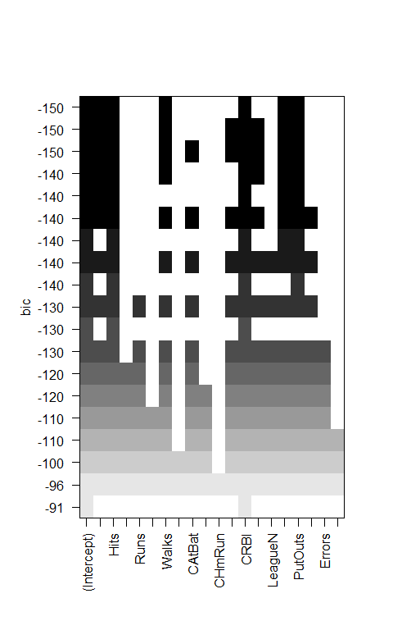

coef(regfit.full,7)

## (Intercept) Hits Walks CAtBat CHits CHmRun   
## 79.4509472 1.2833513 3.2274264 -0.3752350 1.4957073 1.4420538   
## DivisionW PutOuts   
## -129.9866432 0.2366813

coef(regfit.fwd,7)

## (Intercept) AtBat Hits Walks CRBI CWalks   
## 109.7873062 -1.9588851 7.4498772 4.9131401 0.8537622 -0.3053070   
## DivisionW PutOuts   
## -127.1223928 0.2533404

coef(regfit.bwd,7)

## (Intercept) AtBat Hits Walks CRuns CWalks   
## 105.6487488 -1.9762838 6.7574914 6.0558691 1.1293095 -0.7163346   
## DivisionW PutOuts   
## -116.1692169 0.3028847

## 6.5.3 Choosing among models using the validation set approach and cross validation

set.seed(1)  
train=sample(c(TRUE,FALSE),nrow(Hitters),rep=TRUE)  
test=(!train)

regfit.best <- regsubsets(Salary~.,data=Hitters[train,],nvmax=19)  
test.mat <- model.matrix(Salary~.,data=Hitters[test,])

val.errors <- rep(NA,19)  
for(i in 1:19){  
 coefi <- coef(regfit.best,id=i)  
 pred <- test.mat[,names(coefi)]%*%coefi  
 val.errors[i]=mean((Hitters$Salary[test]-pred)^2)  
}

val.errors

## [1] 164377.3 144405.5 152175.7 145198.4 137902.1 139175.7 126849.0 136191.4  
## [9] 132889.6 135434.9 136963.3 140694.9 140690.9 141951.2 141508.2 142164.4  
## [17] 141767.4 142339.6 142238.2

which.min(val.errors)

## [1] 7

coef(regfit.best,10)

## (Intercept) AtBat Hits HmRun Walks CAtBat   
## 71.8074075 -1.5038124 5.9130470 -11.5241809 8.4349759 -0.1654850   
## CRuns CRBI CWalks DivisionW PutOuts   
## 1.7064330 0.7903694 -0.9107515 -109.5616997 0.2426078

predict.regsubsets <- function(object,newdata,id,...){  
 form <- as.formula(object$call[[2]])  
 mat <- model.matrix(form,newdata)  
 coefi <- coef(object,id=id)  
 xvars <- names(coefi)  
 mat[,xvars]%*%coefi  
}

regfit.best <- regsubsets(Salary~.,data=Hitters,nvmax=19)  
coef(regfit.best,10)

## (Intercept) AtBat Hits Walks CAtBat CRuns   
## 162.5354420 -2.1686501 6.9180175 5.7732246 -0.1300798 1.4082490   
## CRBI CWalks DivisionW PutOuts Assists   
## 0.7743122 -0.8308264 -112.3800575 0.2973726 0.2831680

k <- 10   
set.seed(1)  
folds <- sample(1:k,nrow(Hitters),replace=T)  
cv.errors <- matrix(NA,k,19,dimnames=list(NULL,paste(1:19)))

for (j in 1:k){  
 best.fit <- regsubsets(Salary~.,data=Hitters[folds!=j,],nvmax=19)  
 for(i in 1:19){  
 pred <- predict(best.fit,Hitters[folds==j,],id=i)  
 cv.errors[j,i]=mean((Hitters$Salary[folds==j]-pred)^2)  
 }  
}

mean.cv.errors <- apply(cv.errors,2,mean)  
mean.cv.errors

## 1 2 3 4 5 6 7 8   
## 149821.1 130922.0 139127.0 131028.8 131050.2 119538.6 124286.1 113580.0   
## 9 10 11 12 13 14 15 16   
## 115556.5 112216.7 113251.2 115755.9 117820.8 119481.2 120121.6 120074.3   
## 17 18 19   
## 120084.8 120085.8 120403.5

par(mfrow=c(1,1))  
plot(mean.cv.errors,type="b")

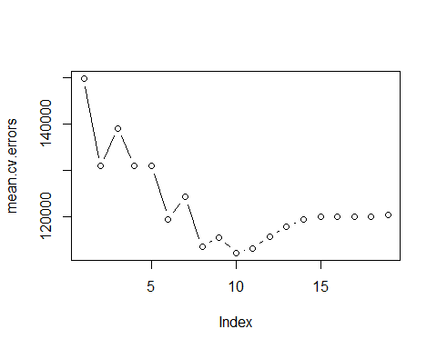

reg.best <- regsubsets(Salary~.,data=Hitters,nvmax=19)  
coef(reg.best,11)

## (Intercept) AtBat Hits Walks CAtBat CRuns   
## 135.7512195 -2.1277482 6.9236994 5.6202755 -0.1389914 1.4553310   
## CRBI CWalks LeagueN DivisionW PutOuts Assists   
## 0.7852528 -0.8228559 43.1116152 -111.1460252 0.2894087 0.2688277

# 6.6 Lab2: Ridge Regression and the Lasso

## 6.6.1 Ridge regression

x <- model.matrix(Salary~.,Hitters)[,-1]  
y <- Hitters$Salary

#install.packages("glmnet")  
library(glmnet)

## Warning: package 'glmnet' was built under R version 4.0.5

## Loading required package: Matrix

## Loaded glmnet 4.1-1

grid <- 10^seq(10, -2, length=100)  
ridge.mod <- glmnet(x,y,alpha=0,lambda=grid)

plot(ridge.mod)

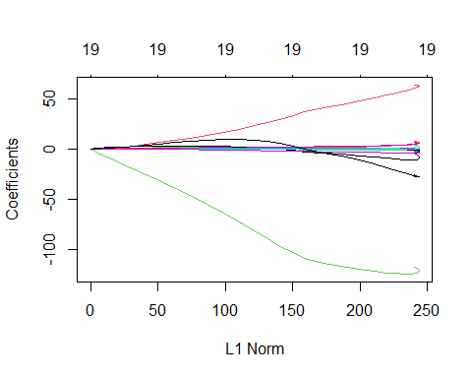

dim(coef(ridge.mod))

## [1] 20 100

ridge.mod$lambda[50]

## [1] 11497.57

coef(ridge.mod)[,50]

## (Intercept) AtBat Hits HmRun Runs   
## 407.356050200 0.036957182 0.138180344 0.524629976 0.230701523   
## RBI Walks Years CAtBat CHits   
## 0.239841459 0.289618741 1.107702929 0.003131815 0.011653637   
## CHmRun CRuns CRBI CWalks LeagueN   
## 0.087545670 0.023379882 0.024138320 0.025015421 0.085028114   
## DivisionW PutOuts Assists Errors NewLeagueN   
## -6.215440973 0.016482577 0.002612988 -0.020502690 0.301433531

ridge.mod$lambda[60]

## [1] 705.4802

coef(ridge.mod)[,60]

## (Intercept) AtBat Hits HmRun Runs RBI   
## 54.32519950 0.11211115 0.65622409 1.17980910 0.93769713 0.84718546   
## Walks Years CAtBat CHits CHmRun CRuns   
## 1.31987948 2.59640425 0.01083413 0.04674557 0.33777318 0.09355528   
## CRBI CWalks LeagueN DivisionW PutOuts Assists   
## 0.09780402 0.07189612 13.68370191 -54.65877750 0.11852289 0.01606037   
## Errors NewLeagueN   
## -0.70358655 8.61181213

sqrt(sum(coef(ridge.mod)[-1,60]^2))

## [1] 57.11001

predict(ridge.mod, s=50, type="coefficients")[1:20,]

## (Intercept) AtBat Hits HmRun Runs   
## 4.876610e+01 -3.580999e-01 1.969359e+00 -1.278248e+00 1.145892e+00   
## RBI Walks Years CAtBat CHits   
## 8.038292e-01 2.716186e+00 -6.218319e+00 5.447837e-03 1.064895e-01   
## CHmRun CRuns CRBI CWalks LeagueN   
## 6.244860e-01 2.214985e-01 2.186914e-01 -1.500245e-01 4.592589e+01   
## DivisionW PutOuts Assists Errors NewLeagueN   
## -1.182011e+02 2.502322e-01 1.215665e-01 -3.278600e+00 -9.496680e+00

set.seed(1)  
train <- sample(1:nrow(x),nrow(x)/2)  
test <- (-train)  
y.test <- y[test]

ridge.mod <- glmnet(x[train,],y[train],alpha=0,lambda=grid,thresh=1e-12)  
ridge.pred <- predict(ridge.mod, s=4, newx=x[test,])  
mean((ridge.pred-y.test)^2)

## [1] 142199.2

plot(ridge.mod)

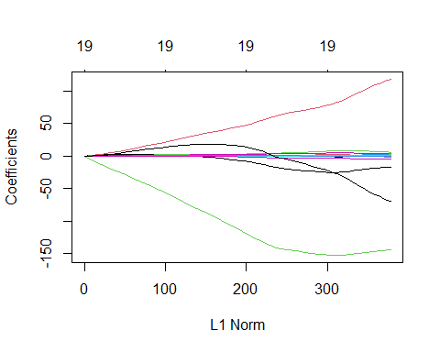

plot(ridge.pred)

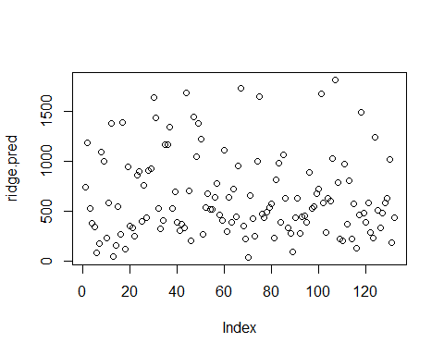

mean((mean(y[train])-y.test)^2)

## [1] 224669.9

ridge.pred <- predict(ridge.mod, s=1e10,newx=x[test,])  
mean((ridge.pred-y.test)^2)

## [1] 224669.8

ridge.pred <- predict(ridge.mod, s=0, newx=x[test,])  
mean((ridge.pred - y.test)^2)

## [1] 167789.8

lm(y~x, subset=train)

##   
## Call:  
## lm(formula = y ~ x, subset = train)  
##   
## Coefficients:  
## (Intercept) xAtBat xHits xHmRun xRuns xRBI   
## 274.0145 -0.3521 -1.6377 5.8145 1.5424 1.1243   
## xWalks xYears xCAtBat xCHits xCHmRun xCRuns   
## 3.7287 -16.3773 -0.6412 3.1632 3.4008 -0.9739   
## xCRBI xCWalks xLeagueN xDivisionW xPutOuts xAssists   
## -0.6005 0.3379 119.1486 -144.0831 0.1976 0.6804   
## xErrors xNewLeagueN   
## -4.7128 -71.0951

predict(ridge.mod, s=0, type="coefficients")[1:20,]

## (Intercept) AtBat Hits HmRun Runs RBI   
## 274.2089049 -0.3699455 -1.5370022 5.9129307 1.4811980 1.0772844   
## Walks Years CAtBat CHits CHmRun CRuns   
## 3.7577989 -16.5600387 -0.6313336 3.1115575 3.3297885 -0.9496641   
## CRBI CWalks LeagueN DivisionW PutOuts Assists   
## -0.5694414 0.3300136 118.4000592 -144.2867510 0.1971770 0.6775088   
## Errors NewLeagueN   
## -4.6833775 -70.1616132

set.seed(1)  
cv.out <- cv.glmnet(x[train,],y[train],alpha=0)  
plot(cv.out)

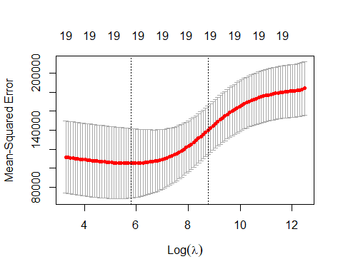

bestlam <- cv.out$lambda.min  
bestlam

## [1] 326.0828

ridge.pred <- predict(ridge.mod, s=bestlam, newx=x[test,])  
mean((ridge.pred-y.test)^2)

## [1] 139856.6

out <- glmnet(x,y,alpha=0)  
predict(out, type="coefficients",s=bestlam)[1:20,]

## (Intercept) AtBat Hits HmRun Runs RBI   
## 15.44383135 0.07715547 0.85911581 0.60103107 1.06369007 0.87936105   
## Walks Years CAtBat CHits CHmRun CRuns   
## 1.62444616 1.35254780 0.01134999 0.05746654 0.40680157 0.11456224   
## CRBI CWalks LeagueN DivisionW PutOuts Assists   
## 0.12116504 0.05299202 22.09143189 -79.04032637 0.16619903 0.02941950   
## Errors NewLeagueN   
## -1.36092945 9.12487767

## 6.6.2 The Lasso

lasso.mod <- glmnet(x[train,],y[train],alpha=1,lambda=grid)  
plot(lasso.mod)

## Warning in regularize.values(x, y, ties, missing(ties), na.rm = na.rm):  
## collapsing to unique 'x' values

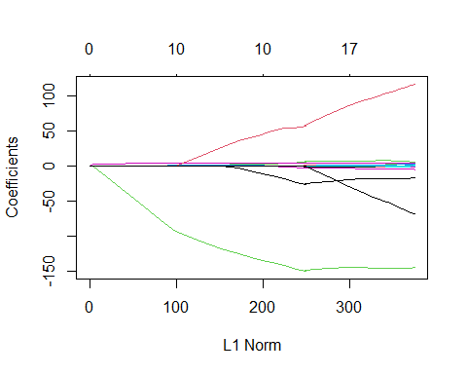

set.seed(1)  
cv.out <- cv.glmnet(x[train,],y[train],alpha=1)  
plot(cv.out)

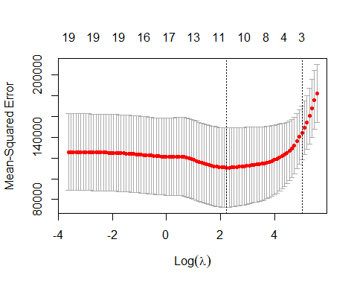

bestlam <- cv.out$lambda.min  
lasso.pred <- predict(lasso.mod, s=bestlam, newx=x[test,])  
mean((lasso.pred-y.test)^2)

## [1] 143673.6

out <- glmnet(x,y,alpha=1,lambda=grid)  
lasso.coef <- predict(out, type="coefficients",s=bestlam)[1:20,]  
lasso.coef

## (Intercept) AtBat Hits HmRun Runs   
## 1.27479059 -0.05497143 2.18034583 0.00000000 0.00000000   
## RBI Walks Years CAtBat CHits   
## 0.00000000 2.29192406 -0.33806109 0.00000000 0.00000000   
## CHmRun CRuns CRBI CWalks LeagueN   
## 0.02825013 0.21628385 0.41712537 0.00000000 20.28615023   
## DivisionW PutOuts Assists Errors NewLeagueN   
## -116.16755870 0.23752385 0.00000000 -0.85629148 0.00000000

# 6.7 Lab3: PCR and PLS Regression

## 6.7.1 Principal Components Regression

#install.packages("pls")  
library(pls)

## Warning: package 'pls' was built under R version 4.0.5

##   
## Attaching package: 'pls'

## The following object is masked from 'package:stats':  
##   
## loadings

set.seed(2)  
pcr.fit <- pcr(Salary~., data=Hitters, scale=T, validation="CV")  
summary(pcr.fit)

## Data: X dimension: 263 19   
## Y dimension: 263 1  
## Fit method: svdpc  
## Number of components considered: 19  
##   
## VALIDATION: RMSEP  
## Cross-validated using 10 random segments.  
## (Intercept) 1 comps 2 comps 3 comps 4 comps 5 comps 6 comps  
## CV 452 351.9 353.2 355.0 352.8 348.4 343.6  
## adjCV 452 351.6 352.7 354.4 352.1 347.6 342.7  
## 7 comps 8 comps 9 comps 10 comps 11 comps 12 comps 13 comps  
## CV 345.5 347.7 349.6 351.4 352.1 353.5 358.2  
## adjCV 344.7 346.7 348.5 350.1 350.7 352.0 356.5  
## 14 comps 15 comps 16 comps 17 comps 18 comps 19 comps  
## CV 349.7 349.4 339.9 341.6 339.2 339.6  
## adjCV 348.0 347.7 338.2 339.7 337.2 337.6  
##   
## TRAINING: % variance explained  
## 1 comps 2 comps 3 comps 4 comps 5 comps 6 comps 7 comps 8 comps  
## X 38.31 60.16 70.84 79.03 84.29 88.63 92.26 94.96  
## Salary 40.63 41.58 42.17 43.22 44.90 46.48 46.69 46.75  
## 9 comps 10 comps 11 comps 12 comps 13 comps 14 comps 15 comps  
## X 96.28 97.26 97.98 98.65 99.15 99.47 99.75  
## Salary 46.86 47.76 47.82 47.85 48.10 50.40 50.55  
## 16 comps 17 comps 18 comps 19 comps  
## X 99.89 99.97 99.99 100.00  
## Salary 53.01 53.85 54.61 54.61

plot(pcr.fit$projection)

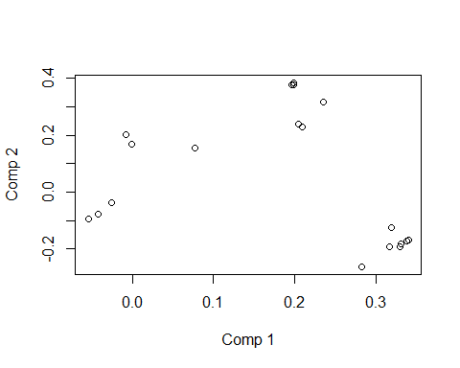

validationplot(pcr.fit, val.type="MSEP")

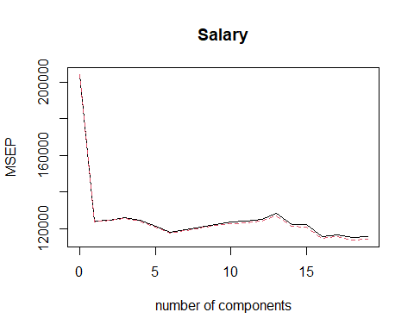

set.seed(1)  
pcr.fit <- pcr(Salary~., data=Hitters, subset=train, scale=T, validation="CV")  
validationplot(pcr.fit, val.type="MSEP")

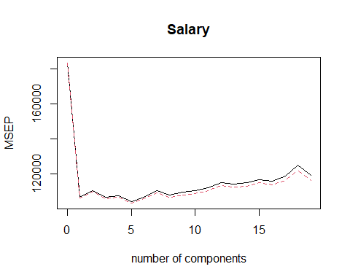

pcr.pred <- predict(pcr.fit, x[test,],ncomp=7)  
mean((pcr.pred - y.test)^2)

## [1] 140751.3

pcr.fit <- pcr(y~x, scale=T, ncomp=7)  
summary(pcr.fit)

## Data: X dimension: 263 19   
## Y dimension: 263 1  
## Fit method: svdpc  
## Number of components considered: 7  
## TRAINING: % variance explained  
## 1 comps 2 comps 3 comps 4 comps 5 comps 6 comps 7 comps  
## X 38.31 60.16 70.84 79.03 84.29 88.63 92.26  
## y 40.63 41.58 42.17 43.22 44.90 46.48 46.69

## 6.7.2 Partial Least Squares

set.seed(1)  
pls.fit <- plsr(Salary~., data=Hitters, subset=train, scale=T, validation="CV")  
summary(pls.fit)

## Data: X dimension: 131 19   
## Y dimension: 131 1  
## Fit method: kernelpls  
## Number of components considered: 19  
##   
## VALIDATION: RMSEP  
## Cross-validated using 10 random segments.  
## (Intercept) 1 comps 2 comps 3 comps 4 comps 5 comps 6 comps  
## CV 428.3 325.5 329.9 328.8 339.0 338.9 340.1  
## adjCV 428.3 325.0 328.2 327.2 336.6 336.1 336.6  
## 7 comps 8 comps 9 comps 10 comps 11 comps 12 comps 13 comps  
## CV 339.0 347.1 346.4 343.4 341.5 345.4 356.4  
## adjCV 336.2 343.4 342.8 340.2 338.3 341.8 351.1  
## 14 comps 15 comps 16 comps 17 comps 18 comps 19 comps  
## CV 348.4 349.1 350.0 344.2 344.5 345.0  
## adjCV 344.2 345.0 345.9 340.4 340.6 341.1  
##   
## TRAINING: % variance explained  
## 1 comps 2 comps 3 comps 4 comps 5 comps 6 comps 7 comps 8 comps  
## X 39.13 48.80 60.09 75.07 78.58 81.12 88.21 90.71  
## Salary 46.36 50.72 52.23 53.03 54.07 54.77 55.05 55.66  
## 9 comps 10 comps 11 comps 12 comps 13 comps 14 comps 15 comps  
## X 93.17 96.05 97.08 97.61 97.97 98.70 99.12  
## Salary 55.95 56.12 56.47 56.68 57.37 57.76 58.08  
## 16 comps 17 comps 18 comps 19 comps  
## X 99.61 99.70 99.95 100.00  
## Salary 58.17 58.49 58.56 58.62

plot(pls.fit)

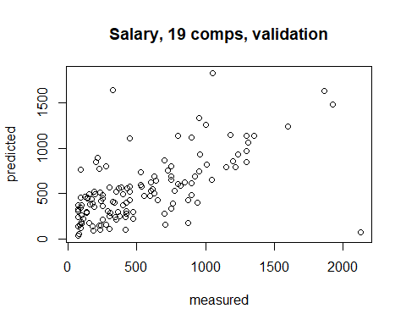

validationplot(pls.fit, val.type="MSEP")

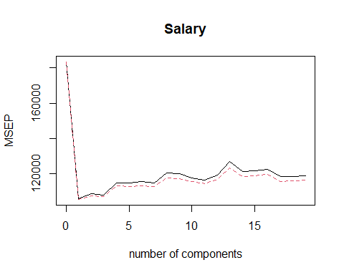

pls.pred <- predict(pls.fit,x[test,],ncomp=2)  
mean((pls.pred-y.test)^2)

## [1] 145367.7

pls.fit <- plsr(Salary~., data=Hitters, scale=T, ncomp=2)  
summary(pls.fit)

## Data: X dimension: 263 19   
## Y dimension: 263 1  
## Fit method: kernelpls  
## Number of components considered: 2  
## TRAINING: % variance explained  
## 1 comps 2 comps  
## X 38.08 51.03  
## Salary 43.05 46.40

# 7.8 Lab: Non-Linear Modeling

## 7.8.1 Polynomial Regression and Step Functions

library(ISLR)  
attach(Wage)

## The following object is masked from ISLR::Auto (pos = 8):  
##   
## year

## The following object is masked from ISLR::Auto (pos = 17):  
##   
## year

fit <- lm(wage~poly(age,4),data=Wage)  
coef(summary(fit))

## Estimate Std. Error t value Pr(>|t|)  
## (Intercept) 111.70361 0.7287409 153.283015 0.000000e+00  
## poly(age, 4)1 447.06785 39.9147851 11.200558 1.484604e-28  
## poly(age, 4)2 -478.31581 39.9147851 -11.983424 2.355831e-32  
## poly(age, 4)3 125.52169 39.9147851 3.144742 1.678622e-03  
## poly(age, 4)4 -77.91118 39.9147851 -1.951938 5.103865e-02

fit2 <- lm(wage~poly(age,4,raw=T),data=Wage)  
coef(summary(fit2))

## Estimate Std. Error t value Pr(>|t|)  
## (Intercept) -1.841542e+02 6.004038e+01 -3.067172 0.0021802539  
## poly(age, 4, raw = T)1 2.124552e+01 5.886748e+00 3.609042 0.0003123618  
## poly(age, 4, raw = T)2 -5.638593e-01 2.061083e-01 -2.735743 0.0062606446  
## poly(age, 4, raw = T)3 6.810688e-03 3.065931e-03 2.221409 0.0263977518  
## poly(age, 4, raw = T)4 -3.203830e-05 1.641359e-05 -1.951938 0.0510386498

fit2a <- lm(wage~age+I(age^2)+I(age^3)+I(age^4),data=Wage)  
coef(fit2a)

## (Intercept) age I(age^2) I(age^3) I(age^4)   
## -1.841542e+02 2.124552e+01 -5.638593e-01 6.810688e-03 -3.203830e-05

fit2b <- lm(wage~cbind(age,age^2,age^3,age^4),data=Wage)  
coef(fit2b)

## (Intercept) cbind(age, age^2, age^3, age^4)age   
## -1.841542e+02 2.124552e+01   
## cbind(age, age^2, age^3, age^4) cbind(age, age^2, age^3, age^4)   
## -5.638593e-01 6.810688e-03   
## cbind(age, age^2, age^3, age^4)   
## -3.203830e-05

agelims <- range(age)  
age.grid <- seq(from=agelims[1],to=agelims[2])  
preds <- predict(fit, newdata=list(age=age.grid),se=T)  
se.bands <- cbind(preds$fit+2*preds$se.fit,preds$fit-2*preds$se.fit)

par(mfrow=c(1,2),mar=c(4.5,4.5,1,1),oma=c(0,0,4,0))  
plot(age, wage, xlim=agelims,cex=0.5,col="darkgrey")  
title("Degree-4 Polynomial", outer=T)  
lines(age.grid, preds$fit,lwd=2,col="blue")  
matlines(age.grid,se.bands,lwd=1,col="blue",lty=3)

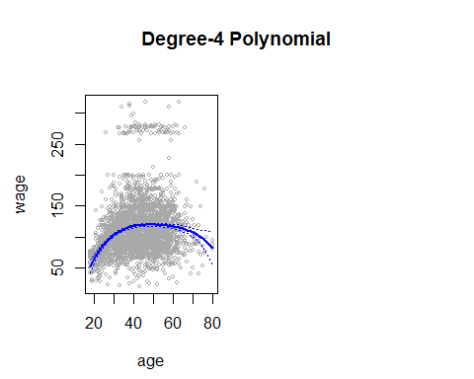

preds2 <- predict(fit2, newdata=list(age=age.grid),se=T)  
max(abs(preds$fit-preds2$fit))

## [1] 7.81597e-11

fit.1 <- lm(wage~age, data=Wage)  
fit.2 <- lm(wage~poly(age,2),data=Wage)  
fit.3 <- lm(wage~poly(age,3),data=Wage)  
fit.4 <- lm(wage~poly(age,4),data=Wage)  
fit.5 <- lm(wage~poly(age,5),data=Wage)  
anova(fit.1,fit.2,fit.3,fit.4,fit.5)

## Analysis of Variance Table  
##   
## Model 1: wage ~ age  
## Model 2: wage ~ poly(age, 2)  
## Model 3: wage ~ poly(age, 3)  
## Model 4: wage ~ poly(age, 4)  
## Model 5: wage ~ poly(age, 5)  
## Res.Df RSS Df Sum of Sq F Pr(>F)   
## 1 2998 5022216   
## 2 2997 4793430 1 228786 143.5931 < 2.2e-16 ***  
## 3 2996 4777674 1 15756 9.8888 0.001679 **   
## 4 2995 4771604 1 6070 3.8098 0.051046 .   
## 5 2994 4770322 1 1283 0.8050 0.369682   
## ---  
## Signif. codes: 0 '***' 0.001 '**' 0.01 '*' 0.05 '.' 0.1 ' ' 1

coef(summary(fit.5))

## Estimate Std. Error t value Pr(>|t|)  
## (Intercept) 111.70361 0.7287647 153.2780243 0.000000e+00  
## poly(age, 5)1 447.06785 39.9160847 11.2001930 1.491111e-28  
## poly(age, 5)2 -478.31581 39.9160847 -11.9830341 2.367734e-32  
## poly(age, 5)3 125.52169 39.9160847 3.1446392 1.679213e-03  
## poly(age, 5)4 -77.91118 39.9160847 -1.9518743 5.104623e-02  
## poly(age, 5)5 -35.81289 39.9160847 -0.8972045 3.696820e-01

(-11.983)^2

## [1] 143.5923

fit.1 <- lm(wage~education+age,data=Wage)  
fit.2 <- lm(wage~education+poly(age,2),data=Wage)  
fit.3 <- lm(wage~education+poly(age,3),data=Wage)  
anova(fit.1,fit.2,fit.3)

## Analysis of Variance Table  
##   
## Model 1: wage ~ education + age  
## Model 2: wage ~ education + poly(age, 2)  
## Model 3: wage ~ education + poly(age, 3)  
## Res.Df RSS Df Sum of Sq F Pr(>F)   
## 1 2994 3867992   
## 2 2993 3725395 1 142597 114.6969 <2e-16 ***  
## 3 2992 3719809 1 5587 4.4936 0.0341 *   
## ---  
## Signif. codes: 0 '***' 0.001 '**' 0.01 '*' 0.05 '.' 0.1 ' ' 1

fit <- glm(I(wage>250)~poly(age,4),data=Wage,family=binomial)  
summary(fit)

##   
## Call:  
## glm(formula = I(wage > 250) ~ poly(age, 4), family = binomial,   
## data = Wage)  
##   
## Deviance Residuals:   
## Min 1Q Median 3Q Max   
## -0.3110 -0.2607 -0.2488 -0.1791 3.7859   
##   
## Coefficients:  
## Estimate Std. Error z value Pr(>|z|)   
## (Intercept) -4.3012 0.3451 -12.465 < 2e-16 ***  
## poly(age, 4)1 71.9642 26.1176 2.755 0.00586 **   
## poly(age, 4)2 -85.7729 35.9043 -2.389 0.01690 *   
## poly(age, 4)3 34.1626 19.6890 1.735 0.08272 .   
## poly(age, 4)4 -47.4008 24.0909 -1.968 0.04912 *   
## ---  
## Signif. codes: 0 '***' 0.001 '**' 0.01 '*' 0.05 '.' 0.1 ' ' 1  
##   
## (Dispersion parameter for binomial family taken to be 1)  
##   
## Null deviance: 730.53 on 2999 degrees of freedom  
## Residual deviance: 701.22 on 2995 degrees of freedom  
## AIC: 711.22  
##   
## Number of Fisher Scoring iterations: 9

preds <- predict(fit, newdata=list(age=age.grid),se=T)

pfit <- exp(preds$fit)/(1+exp(preds$fit))  
se.bands.logit <- cbind(preds$fit+2*preds$se.fit,preds$fit-2*preds$se.fit)  
se.bands <- exp(se.bands.logit)/(1+exp(se.bands.logit))

preds <- predict(fit, newdata=list(age=age.grid),type="response",se=T)

plot(age,I(wage>250),xlim=agelims,type="n",ylim=c(0,0.2))  
points(jitter(age),I((wage>250)/5),cex=0.5,pch="|",col="darkgrey")  
lines(age.grid,pfit,lwd=2,col="blue")  
matlines(age.grid,se.bands,lwd=1,col="blue",lty=3)

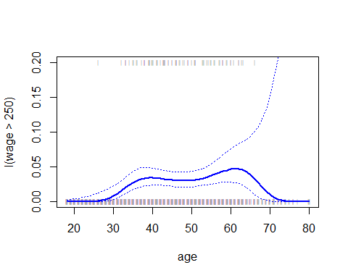

table(cut(age,4))

##   
## (17.9,33.5] (33.5,49] (49,64.5] (64.5,80.1]   
## 750 1399 779 72

fit <- lm(wage~cut(age,4),data=Wage)  
coef(summary(fit))

## Estimate Std. Error t value Pr(>|t|)  
## (Intercept) 94.158392 1.476069 63.789970 0.000000e+00  
## cut(age, 4)(33.5,49] 24.053491 1.829431 13.148074 1.982315e-38  
## cut(age, 4)(49,64.5] 23.664559 2.067958 11.443444 1.040750e-29  
## cut(age, 4)(64.5,80.1] 7.640592 4.987424 1.531972 1.256350e-01

## 7.8.2 Splines

#install.packages("splines")  
library(splines)  
fit <- lm(wage~bs(age,knots=c(25,40,60)),data=Wage)  
pred <- predict(fit, newdata=list(age=age.grid),se=T)  
plot(age,wage,col="gray")  
lines(age.grid,pred$fit,lwd=2)  
lines(age.grid,pred$fit+2*pred$se,lty="dashed")  
lines(age.grid,pred$fit-2*pred$se,lty="dashed")

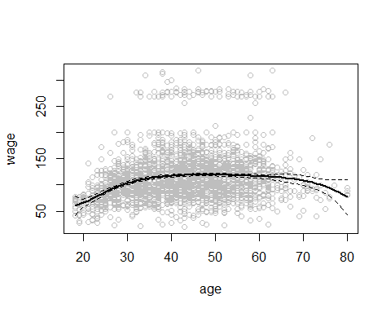

dim(bs(age,knots=c(25,40,60)))

## [1] 3000 6

dim(bs(age,df=6))

## [1] 3000 6

attr(bs(age,df=6),"knots")

## 25% 50% 75%   
## 33.75 42.00 51.00

fit2 <- lm(wage~ns(age,df=4),data=Wage)  
pred2 <- predict(fit2, newdata=list(age=age.grid),se=T)  
plot(age,wage)  
lines(age.grid, pred2$fit,col="red",lwd=2)

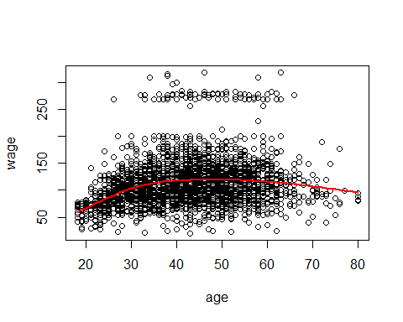

plot(age,wage,xlim=agelims,cex=0.5,col="darkgrey")  
title("Smoothing Spline")  
fit <- smooth.spline(age,wage,df=16)  
fit2 <- smooth.spline(age,wage,cv=T)

## Warning in smooth.spline(age, wage, cv = T): cross-validation with non-unique  
## 'x' values seems doubtful

fit2$df

## [1] 6.794596

lines(fit,col="red",lwd=2)  
lines(fit2,col="blue",lwd=2)  
legend("topright",legend=c("16 DF", "6.8 DF"), col=c("red","blue"),lty=1,lwd=2,cex=0.8)

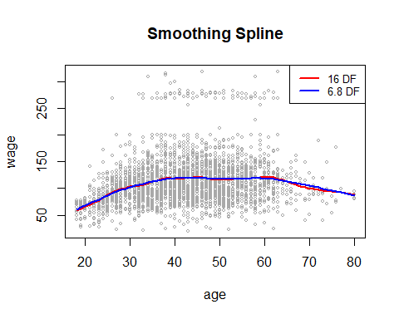

plot(age,wage,xlim=agelims,cex=0.5,col="darkgrey")  
title("Local Regression")  
fit <- loess(wage~age, span=0.2, data=Wage)  
fit2 <- loess(wage~age, span=0.5, data=Wage)  
lines(age.grid, predict(fit,data.frame(age=age.grid)),col="red",lwd=2)  
lines(age.grid, predict(fit2,data.frame(age=age.grid)),col="blue",lwd=2)  
legend("topright",legend=c("Span=0.2","Span=0.5"),col=c("red","blue"),lty=1,lwd=2,cex=0.8)

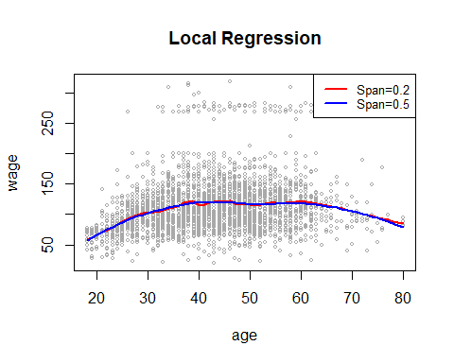

## 7.8.3 GAMs

gam1 <- lm(wage~ns(year,4)+ns(age,5)+education,data=Wage)

#install.packages("gam")  
library(gam)

## Warning: package 'gam' was built under R version 4.0.5

## Loading required package: foreach

## Warning: package 'foreach' was built under R version 4.0.5

## Loaded gam 1.20

gam.m3 <- gam(wage~s(year,4)+s(age,5)+education,data=Wage)

par(mfrow=c(1,3))  
plot(gam.m3,se=T,col="blue")

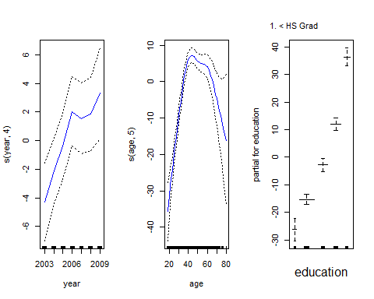

plot.Gam(gam1,se=T,col="red")

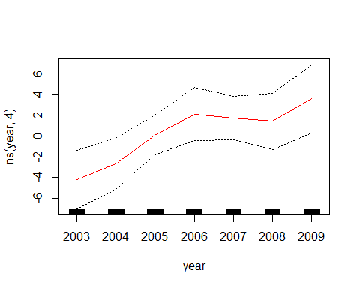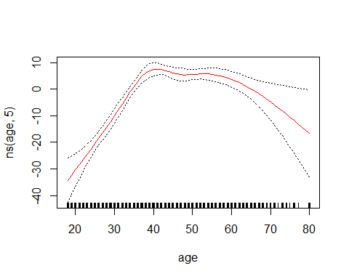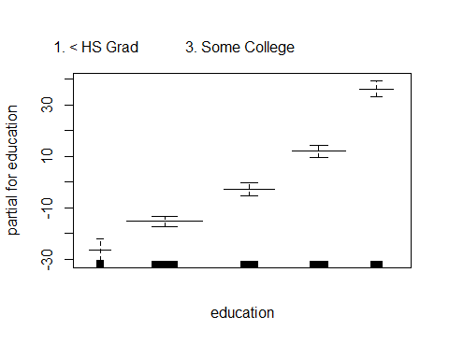

gam.m1 <- gam(wage~s(age,5)+education,data=Wage)  
gam.m2 <- gam(wage~year+s(age,5)+education,data=Wage)  
gam.m3 <- gam(wage~s(year,4)+s(age,5)+education,data=Wage)  
anova(gam.m1,gam.m2,gam.m3,test="F")

## Analysis of Deviance Table  
##   
## Model 1: wage ~ s(age, 5) + education  
## Model 2: wage ~ year + s(age, 5) + education  
## Model 3: wage ~ s(year, 4) + s(age, 5) + education  
## Resid. Df Resid. Dev Df Deviance F Pr(>F)   
## 1 2990 3711731   
## 2 2989 3693842 1 17889.2 14.4771 0.0001447 ***  
## 3 2986 3689770 3 4071.1 1.0982 0.3485661   
## ---  
## Signif. codes: 0 '***' 0.001 '**' 0.01 '*' 0.05 '.' 0.1 ' ' 1

summary(gam.m3)

##   
## Call: gam(formula = wage ~ s(year, 4) + s(age, 5) + education, data = Wage)  
## Deviance Residuals:  
## Min 1Q Median 3Q Max   
## -119.43 -19.70 -3.33 14.17 213.48   
##   
## (Dispersion Parameter for gaussian family taken to be 1235.69)  
##   
## Null Deviance: 5222086 on 2999 degrees of freedom  
## Residual Deviance: 3689770 on 2986 degrees of freedom  
## AIC: 29887.75   
##   
## Number of Local Scoring Iterations: NA   
##   
## Anova for Parametric Effects  
## Df Sum Sq Mean Sq F value Pr(>F)   
## s(year, 4) 1 27162 27162 21.981 2.877e-06 ***  
## s(age, 5) 1 195338 195338 158.081 < 2.2e-16 ***  
## education 4 1069726 267432 216.423 < 2.2e-16 ***  
## Residuals 2986 3689770 1236   
## ---  
## Signif. codes: 0 '***' 0.001 '**' 0.01 '*' 0.05 '.' 0.1 ' ' 1  
##   
## Anova for Nonparametric Effects  
## Npar Df Npar F Pr(F)   
## (Intercept)   
## s(year, 4) 3 1.086 0.3537   
## s(age, 5) 4 32.380 <2e-16 ***  
## education   
## ---  
## Signif. codes: 0 '***' 0.001 '**' 0.01 '*' 0.05 '.' 0.1 ' ' 1

preds <- predict(gam.m3,newdata=Wage)

gam.lo <- gam(wage~s(year,df=4)+lo(age,span=0.7)+education,data=Wage)  
plot.Gam(gam.lo,se=T,col="green")

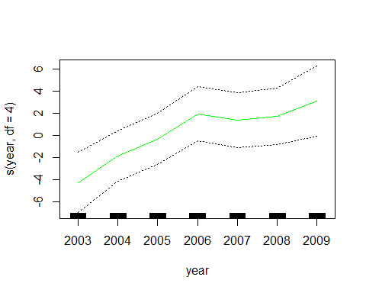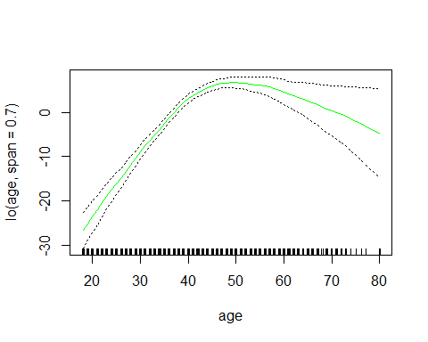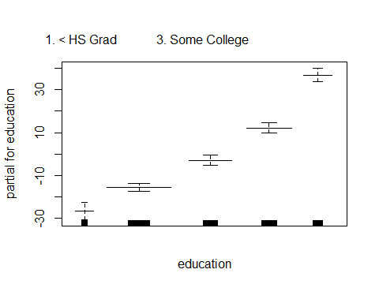

gam.lo.i <- gam(wage~lo(year,age,span=0.5)+education,data=Wage)

## Warning in lo.wam(x, z, wz, fit$smooth, which, fit$smooth.frame, bf.maxit, : liv  
## too small. (Discovered by lowesd)

## Warning in lo.wam(x, z, wz, fit$smooth, which, fit$smooth.frame, bf.maxit, : lv  
## too small. (Discovered by lowesd)

## Warning in lo.wam(x, z, wz, fit$smooth, which, fit$smooth.frame, bf.maxit, : liv  
## too small. (Discovered by lowesd)

## Warning in lo.wam(x, z, wz, fit$smooth, which, fit$smooth.frame, bf.maxit, : lv  
## too small. (Discovered by lowesd)

#install.packages("akima")  
library(akima)

## Warning: package 'akima' was built under R version 4.0.5

plot(gam.lo.i)

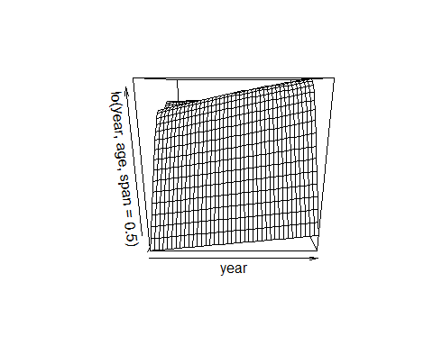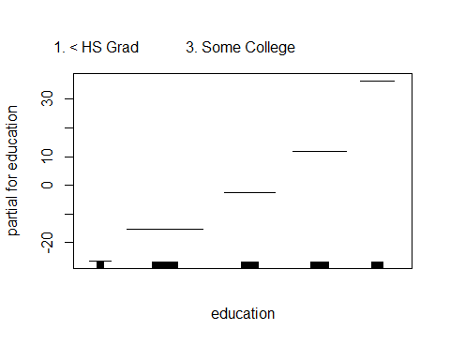

gam.lr <- gam(I(wage>250)~year+s(age,df=5)+education,family=binomial,data=Wage)  
par(mfrow=c(1,3))  
plot(gam.lr,se=T,col="green")

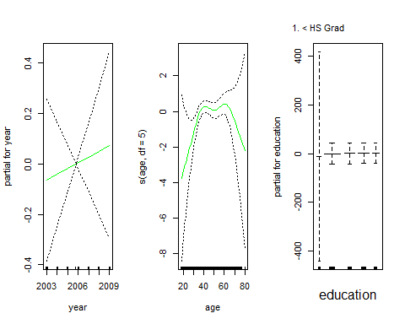

table(education,I(wage>250))

##   
## education FALSE TRUE  
## 1. < HS Grad 268 0  
## 2. HS Grad 966 5  
## 3. Some College 643 7  
## 4. College Grad 663 22  
## 5. Advanced Degree 381 45

gam.lr.s <- gam(I(wage>250)~year+s(age,df=5)+education,family=binomial,data=Wage,subset=(education!="1.< HS Grad"))  
plot(gam.lr.s,se=T,col="green")

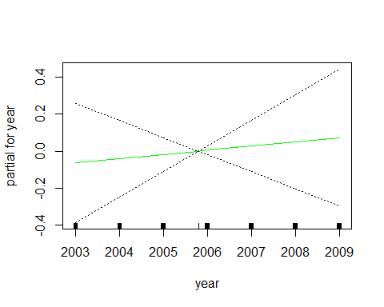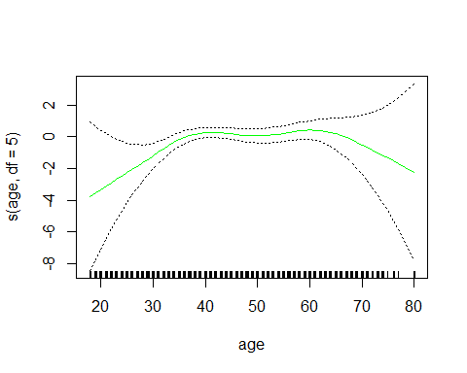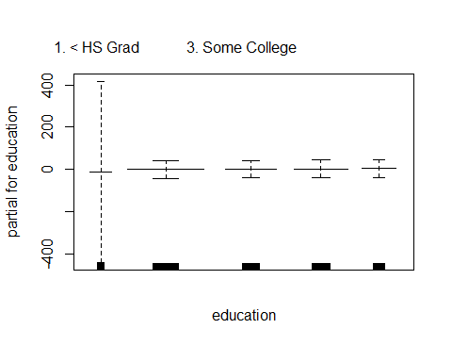

# 8.3 Lab: Decision Trees

## Fitting Classification Trees

#install.packages("tree")  
library(tree)

## Warning: package 'tree' was built under R version 4.0.5

library(ISLR)  
attach(Carseats)

## The following objects are masked from Carseats (pos = 18):  
##   
## Advertising, Age, CompPrice, Education, Income, Population, Price,  
## Sales, ShelveLoc, Urban, US

High <- ifelse(Sales<=8, "No", "Yes")

Carseats <- data.frame(Carseats, High)

#tree.carseats <- tree(High~.-Sales,Carseats)  
#summary(tree.carseats)

#plot(tree.carseats)  
#text(tree.carseats,pretty=0)

#tree.carseats

#set.seed(2)  
#train <- sample(1:nrow(Carseats),200)  
#Carseats.test <- Carseats[-train,]  
#High.test <- High[-train]  
#tree.carseats <- tree(High~CompPrice+Income+Advertising+Population+Price+ShelveLoc+Age+Education+Urban+US, Carseats, subset=train)  
#tree.pred <- predict(tree.carseats, Carseats.test, type="class")  
#table(tree.pred, High.test)  
#(86+57)/200

#set.seed(3)  
#cv.carseats <- cv.tree(tree.carseats,FUN=prune.misclass)  
#names(cv.carseats)

#cv.carseats$size  
#cv.carseats$dev  
#cv.carseats$k  
#cv.carseats$method

#par(mfrow=c(1,2))  
#plot(cv.carseats$size,cv.carseats$dev,type="b")  
#plot(cv.carseats$k,cv.carseats$dev,type="b")

#prune.carseats <- prune.misclass(tree.carseats,best=9)  
#plot(prune.carseats)  
#text(prune.carseats,pretty=0)

#tree.pred <- predict(prune.carseats, Carseats.test, type="class")  
#table(tree.pred, High.test)  
#(94+60)/200

#prune.carseats <- prune.misclass(tree.carseats,best=15)  
#plot(prune.carseats)  
#text(prune.carseats,pretty=0)  
#tree.pred <- predict(prune.carseats, Carseats.test, type="class")  
#table(tree.pred, High.test)  
#(86+62)/200

## 8.3.2 Fitting Regression Trees

library(MASS)  
set.seed(1)  
train <- sample(1:nrow(Boston),nrow(Boston)/2)  
tree.boston <- tree(medv~., Boston, subset=train)  
summary(tree.boston)

##   
## Regression tree:  
## tree(formula = medv ~ ., data = Boston, subset = train)  
## Variables actually used in tree construction:  
## [1] "rm" "lstat" "crim" "age"   
## Number of terminal nodes: 7   
## Residual mean deviance: 10.38 = 2555 / 246   
## Distribution of residuals:  
## Min. 1st Qu. Median Mean 3rd Qu. Max.   
## -10.1800 -1.7770 -0.1775 0.0000 1.9230 16.5800

plot(tree.boston)  
text(tree.boston, pretty=0)

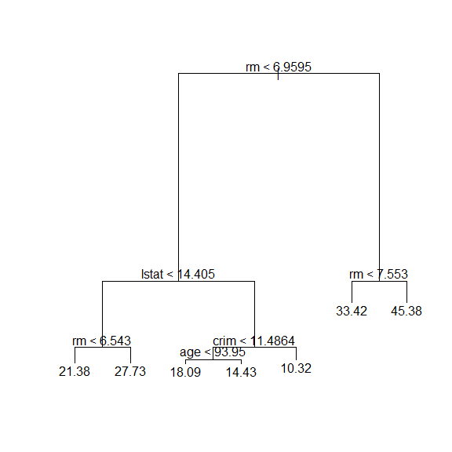

cv.boston <- cv.tree(tree.boston)  
plot(cv.boston$size,cv.boston$dev,type="b")

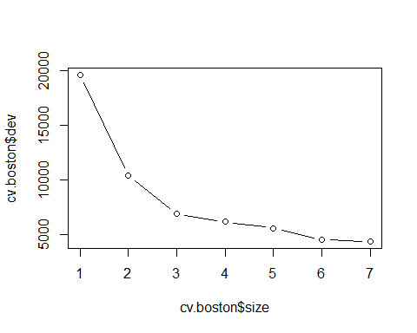

prune.boston <- prune.tree(tree.boston,best=5)  
plot(prune.boston)  
text(prune.boston,pretty=0)

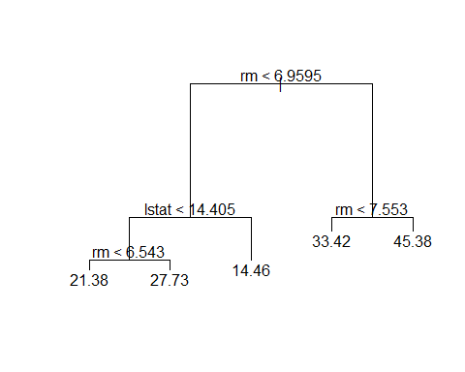

yhat <- predict(tree.boston, newdata=Boston[-train,])  
boston.test <- Boston[-train,"medv"]  
plot(yhat,boston.test)  
abline(0,1)

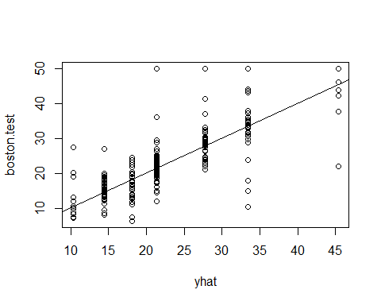

mean((yhat-boston.test)^2)

## [1] 35.28688

## 8.3.3 Bagging and Random Forest

#install.packages("randomForest")  
library(randomForest)

## Warning: package 'randomForest' was built under R version 4.0.5

## randomForest 4.6-14

## Type rfNews() to see new features/changes/bug fixes.

set.seed(1)  
bag.boston <- randomForest(medv~., data=Boston, subset=train, mtry=13, importance=T)  
bag.boston

##   
## Call:  
## randomForest(formula = medv ~ ., data = Boston, mtry = 13, importance = T, subset = train)   
## Type of random forest: regression  
## Number of trees: 500  
## No. of variables tried at each split: 13  
##   
## Mean of squared residuals: 11.39601  
## % Var explained: 85.17

yhat.bag <- predict(bag.boston,newdata <- Boston[-train,])  
plot(yhat.bag,boston.test)  
abline(0,1,col="red")

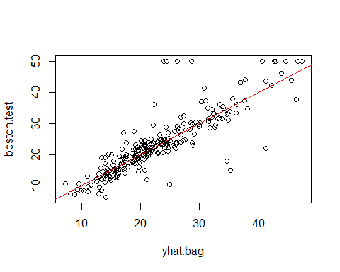

mean((yhat.bag-boston.test)^2)

## [1] 23.59273

bag.boston <- randomForest(medv~., data=Boston, subset=train, mtry=13, ntree=25)  
yhat.bag <- predict(bag.boston,newdata=Boston[-train,])  
mean((yhat.bag-boston.test)^2)

## [1] 23.66716

set.seed(1)  
rf.boston <- randomForest(medv~., data=Boston, subset=train, mtry=6, importance=T)  
yhat.rf <- predict(rf.boston,newdata=Boston[-train,])  
mean((yhat.rf-boston.test)^2)

## [1] 19.62021

importance(rf.boston)

## %IncMSE IncNodePurity  
## crim 16.697017 1076.08786  
## zn 3.625784 88.35342  
## indus 4.968621 609.53356  
## chas 1.061432 52.21793  
## nox 13.518179 709.87339  
## rm 32.343305 7857.65451  
## age 13.272498 612.21424  
## dis 9.032477 714.94674  
## rad 2.878434 95.80598  
## tax 9.118801 364.92479  
## ptratio 8.467062 823.93341  
## black 7.579482 275.62272  
## lstat 27.129817 6027.63740

varImpPlot(rf.boston)

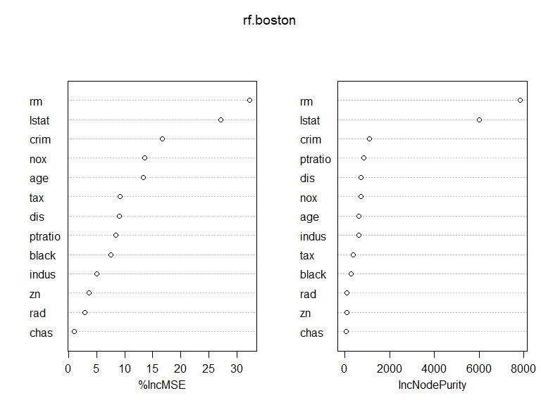

## 8.3.4 Boosting

#install.packages("gbm")  
library(gbm)

## Warning: package 'gbm' was built under R version 4.0.5

## Loaded gbm 2.1.8

set.seed(1)  
boost.boston <- gbm(medv~.,data=Boston[train,],distribution="gaussian",n.trees=5000, interaction.depth=4)  
summary(boost.boston)

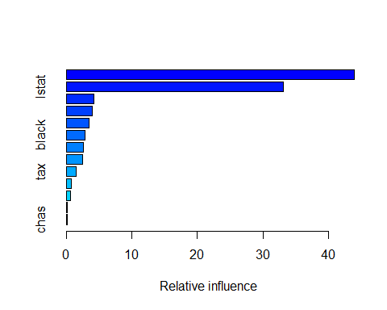

## var rel.inf  
## rm rm 43.9919329  
## lstat lstat 33.1216941  
## crim crim 4.2604167  
## dis dis 4.0111090  
## nox nox 3.4353017  
## black black 2.8267554  
## age age 2.6113938  
## ptratio ptratio 2.5403035  
## tax tax 1.4565654  
## indus indus 0.8008740  
## rad rad 0.6546400  
## zn zn 0.1446149  
## chas chas 0.1443986

par(mfrow=c(1,2))  
plot(boost.boston,i="rm")

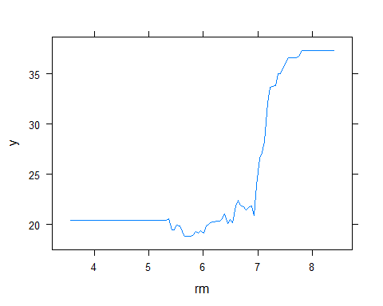

plot(boost.boston,i="lstat")

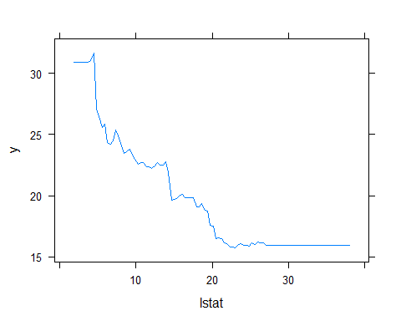

yhat.boost <- predict(boost.boston,newdata=Boston[-train,],n.trees=5000)  
mean((yhat.boost-boston.test)^2)

## [1] 18.84709

boost.boston <- gbm(medv~., data=Boston[train,],distribution="gaussian",n.trees=5000, interaction.depth=4,shrinkage=0.2,verbose=F)  
yhat.boost <- predict(boost.boston, newdata=Boston[-train,],n.trees=5000)  
mean((yhat.boost-boston.test)^2)

## [1] 18.33455

# 9.6 Lab: Support Vector Machines

## 9.6.1 Support Vector Classifier

#install.packages("e1071")  
library(e1071)

## Warning: package 'e1071' was built under R version 4.0.5

set.seed(1)  
x <- matrix(rnorm(20*2),ncol=2)  
y <- c(rep(-1,10),rep(1,10))  
x[y==1,] <- x[y==1,] + 1

plot(x,col=(3-y))

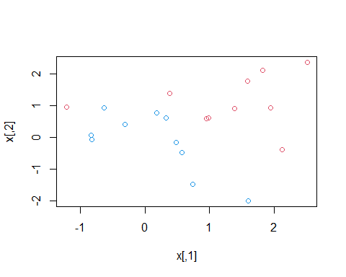

dat <- data.frame(x=x, y=as.factor(y))  
svmfit <- svm(y~., data=dat, kernel="linear",cost=10, scale=F)  
plot(svmfit,dat)

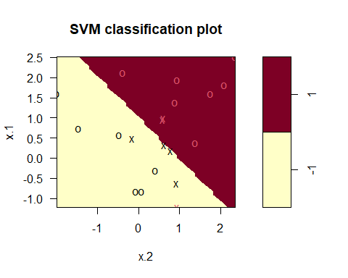

svmfit$index

## [1] 1 2 5 7 14 16 17

summary(svmfit)

##   
## Call:  
## svm(formula = y ~ ., data = dat, kernel = "linear", cost = 10, scale = F)  
##   
##   
## Parameters:  
## SVM-Type: C-classification   
## SVM-Kernel: linear   
## cost: 10   
##   
## Number of Support Vectors: 7  
##   
## ( 4 3 )  
##   
##   
## Number of Classes: 2   
##   
## Levels:   
## -1 1

svmfit <- svm(y~., data=dat, kernel="linear",cost=0.1,scale=F)  
plot(svmfit,dat)

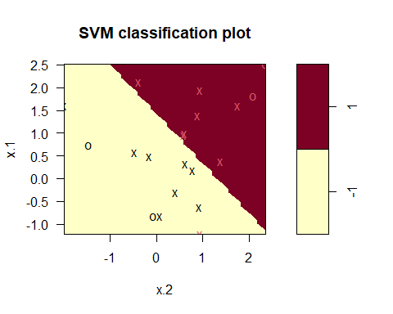

svmfit$index

## [1] 1 2 3 4 5 7 9 10 12 13 14 15 16 17 18 20

set.seed(1)  
tune.out <- tune(svm, y~., data=dat, kernel="linear", ranges=list(cost=c(0.001, 0.01, 0.1, 1, 5, 10, 100)))

summary(tune.out)

##   
## Parameter tuning of 'svm':  
##   
## - sampling method: 10-fold cross validation   
##   
## - best parameters:  
## cost  
## 0.1  
##   
## - best performance: 0.05   
##   
## - Detailed performance results:  
## cost error dispersion  
## 1 1e-03 0.55 0.4377975  
## 2 1e-02 0.55 0.4377975  
## 3 1e-01 0.05 0.1581139  
## 4 1e+00 0.15 0.2415229  
## 5 5e+00 0.15 0.2415229  
## 6 1e+01 0.15 0.2415229  
## 7 1e+02 0.15 0.2415229

plot(tune.out)

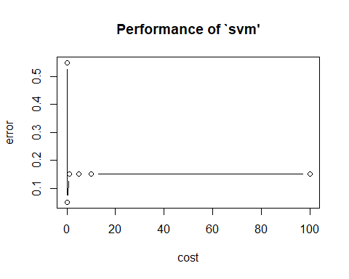

bestmod <- tune.out$best.model  
summary(bestmod)

##   
## Call:  
## best.tune(method = svm, train.x = y ~ ., data = dat, ranges = list(cost = c(0.001,   
## 0.01, 0.1, 1, 5, 10, 100)), kernel = "linear")  
##   
##   
## Parameters:  
## SVM-Type: C-classification   
## SVM-Kernel: linear   
## cost: 0.1   
##   
## Number of Support Vectors: 16  
##   
## ( 8 8 )  
##   
##   
## Number of Classes: 2   
##   
## Levels:   
## -1 1

xtest <- matrix(rnorm(20*2),ncol=2)  
ytest <- sample(c(-1, 1),20, rep=T)  
xtest[ytest==1,] <- xtest[ytest==1,] + 1  
testdat <- data.frame(x=xtest, y=as.factor(ytest))

ypred <- predict(bestmod, testdat)  
table(predict=ypred, truth=testdat$y)

## truth  
## predict -1 1  
## -1 9 1  
## 1 2 8

svmfit <- svm(y~., data=dat, kernel="linear", cost=0.01, scale=F)  
ypred <- predict(svmfit, testdat)  
table(predict=ypred, truth=testdat$y)

## truth  
## predict -1 1  
## -1 11 6  
## 1 0 3

x[y==1,] <- x[y==1,] + 0.5  
plot(x,col=(y+5)/2,pch=19)

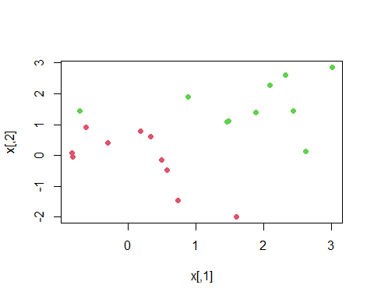

dat <- data.frame(x=x, y=as.factor(y))  
svmfit <- svm(y~., data=dat, kernel="linear",cost=1e5)  
summary(svmfit)

##   
## Call:  
## svm(formula = y ~ ., data = dat, kernel = "linear", cost = 1e+05)  
##   
##   
## Parameters:  
## SVM-Type: C-classification   
## SVM-Kernel: linear   
## cost: 1e+05   
##   
## Number of Support Vectors: 3  
##   
## ( 1 2 )  
##   
##   
## Number of Classes: 2   
##   
## Levels:   
## -1 1

plot(svmfit,dat)

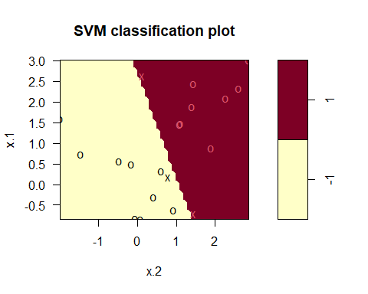

svmfit <- svm(y~., data=dat, kernel="linear", cost=1)  
summary(svmfit)

##   
## Call:  
## svm(formula = y ~ ., data = dat, kernel = "linear", cost = 1)  
##   
##   
## Parameters:  
## SVM-Type: C-classification   
## SVM-Kernel: linear   
## cost: 1   
##   
## Number of Support Vectors: 7  
##   
## ( 4 3 )  
##   
##   
## Number of Classes: 2   
##   
## Levels:   
## -1 1

plot(svmfit,dat)

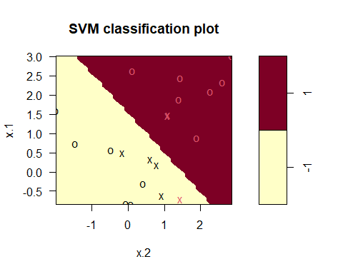

## 9.6.2 Support vector machine

set.seed(1)  
x <- matrix(rnorm(200*2),ncol=2)  
x[1:100,] <- x[1:100,] + 2  
x[101:150,] <- x[101:150,] - 2  
y <- c(rep(1,150),rep(2,50))  
dat <- data.frame(x=x, y=as.factor(y))  
plot(x,col=y)

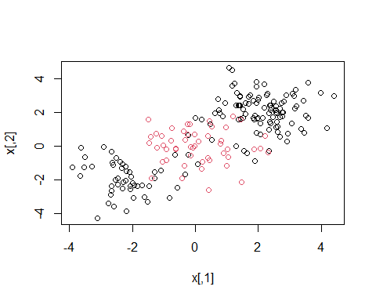

train <- sample(200,100)  
svmfit <- svm(y~., data=dat[train,], kernel="radial", gamma=1, cost=1)  
plot(svmfit, dat[train,])

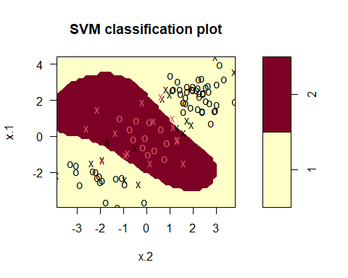

summary(svmfit)

##   
## Call:  
## svm(formula = y ~ ., data = dat[train, ], kernel = "radial", gamma = 1,   
## cost = 1)  
##   
##   
## Parameters:  
## SVM-Type: C-classification   
## SVM-Kernel: radial   
## cost: 1   
##   
## Number of Support Vectors: 31  
##   
## ( 16 15 )  
##   
##   
## Number of Classes: 2   
##   
## Levels:   
## 1 2

svmfit <- svm(y~., data=dat[train,], kernel="radial", gamma=1, cost=1e5)  
plot(svmfit, dat[train,])

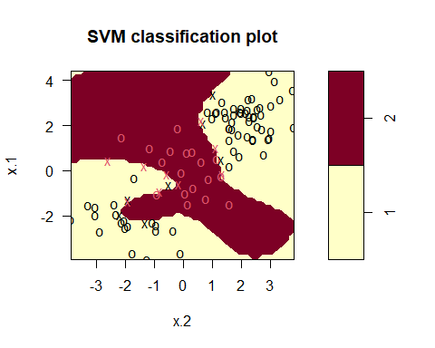

set.seed(1)  
tune.out <- tune(svm, y~., data=dat[train,],kernel="radial",ranges=list(cost=c(0.1,1,10,100,1000),gamma=c(0.5,1,2,3,4)))  
summary(tune.out)

##   
## Parameter tuning of 'svm':  
##   
## - sampling method: 10-fold cross validation   
##   
## - best parameters:  
## cost gamma  
## 1 0.5  
##   
## - best performance: 0.07   
##   
## - Detailed performance results:  
## cost gamma error dispersion  
## 1 1e-01 0.5 0.26 0.15776213  
## 2 1e+00 0.5 0.07 0.08232726  
## 3 1e+01 0.5 0.07 0.08232726  
## 4 1e+02 0.5 0.14 0.15055453  
## 5 1e+03 0.5 0.11 0.07378648  
## 6 1e-01 1.0 0.22 0.16193277  
## 7 1e+00 1.0 0.07 0.08232726  
## 8 1e+01 1.0 0.09 0.07378648  
## 9 1e+02 1.0 0.12 0.12292726  
## 10 1e+03 1.0 0.11 0.11005049  
## 11 1e-01 2.0 0.27 0.15670212  
## 12 1e+00 2.0 0.07 0.08232726  
## 13 1e+01 2.0 0.11 0.07378648  
## 14 1e+02 2.0 0.12 0.13165612  
## 15 1e+03 2.0 0.16 0.13498971  
## 16 1e-01 3.0 0.27 0.15670212  
## 17 1e+00 3.0 0.07 0.08232726  
## 18 1e+01 3.0 0.08 0.07888106  
## 19 1e+02 3.0 0.13 0.14181365  
## 20 1e+03 3.0 0.15 0.13540064  
## 21 1e-01 4.0 0.27 0.15670212  
## 22 1e+00 4.0 0.07 0.08232726  
## 23 1e+01 4.0 0.09 0.07378648  
## 24 1e+02 4.0 0.13 0.14181365  
## 25 1e+03 4.0 0.15 0.13540064

table(true=dat[-train,"y"],pred=predict(tune.out$best.model,newx=dat[-train,]))

## pred  
## true 1 2  
## 1 54 23  
## 2 17 6

## 9.6.3 ROC Curves

#install.packages("ROCR")  
library(ROCR)

## Warning: package 'ROCR' was built under R version 4.0.5

rocplot <- function(pred, truth, ...){  
 predob = prediction(pred, truth)  
 perf = performance(predob, "tpr", "fpr")  
 plot(perf, ...)  
}

svmfit.opt <- svm(y~., data=dat[train,],kernel="radial",gamma=2, cost=1, decision.values=T)  
fitted <- attributes(predict(svmfit.opt,dat[train,],decision.values=T))$decision.values

par(mfrow=c(1,2))  
rocplot(fitted,dat[train,"y"],main="Training Data")

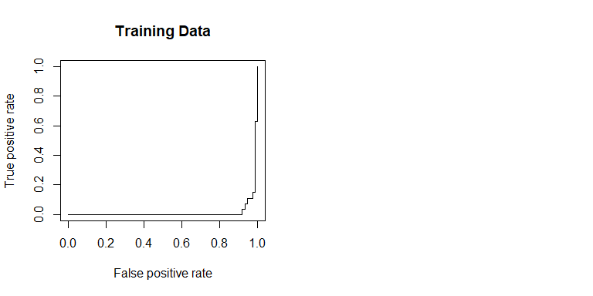

svmfit.flex <- svm(y~., data=dat[train,],kernel="radial",gamma=50, cost=1, decision.values=T)  
fitted <- attributes(predict(svmfit.flex,dat[train,],decision.values=T))$decision.values  
rocplot(fitted,dat[train,"y"],col="red")

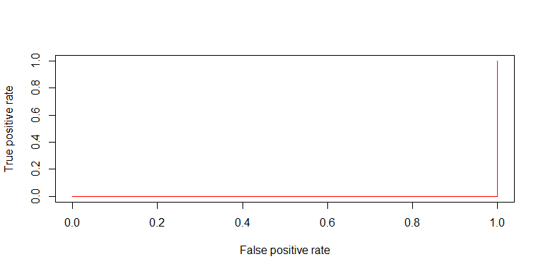

fitted <- attributes(predict(svmfit.opt,dat[-train,],decision.values=T))$decision.values  
rocplot(fitted,dat[-train,"y"],main="Test Data")  
fitted <- attributes(predict(svmfit.flex,dat[-train,],decision.values=T))$decision.values  
rocplot(fitted,dat[-train,"y"],add=T,col="red")

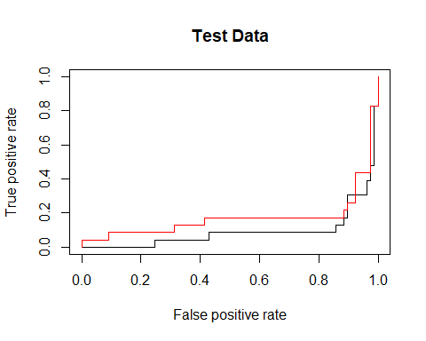

## 9.6.4 SVM With Multiple Classes

set.seed(1)  
x <- rbind(x,matrix(rnorm(50*2),ncol=2))  
y <- c(y,rep(0,50))  
x[y==0,2]=x[y==0,2]+2  
dat<-data.frame(x=x,y=as.factor(y))  
par(mfrow=c(1,1))  
plot(x,col=(y+1))

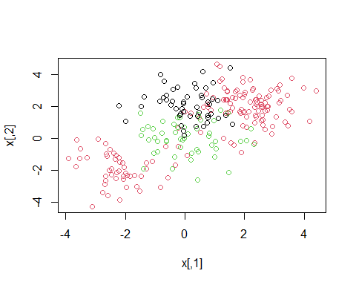

svmfit <- svm(y~., data=dat, kernel="radial",cost=10,gamma=1)  
plot(svmfit,dat)

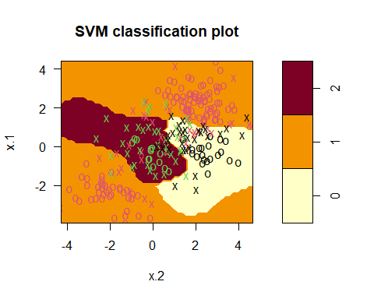

## 9.6.5 Application to Gene Expression Data

library(ISLR)  
names(Khan)

## [1] "xtrain" "xtest" "ytrain" "ytest"

dim(Khan$xtrain)

## [1] 63 2308

dim(Khan$xtest)

## [1] 20 2308

length(Khan$ytrain)

## [1] 63

length(Khan$ytest)

## [1] 20

table(Khan$ytrain)

##   
## 1 2 3 4   
## 8 23 12 20

table(Khan$ytest)

##   
## 1 2 3 4   
## 3 6 6 5

dat <- data.frame(x=Khan$xtrain,y=as.factor(Khan$ytrain))  
out <- svm(y~., data=dat, kernel="linear", cost=10)  
summary(out)

##   
## Call:  
## svm(formula = y ~ ., data = dat, kernel = "linear", cost = 10)  
##   
##   
## Parameters:  
## SVM-Type: C-classification   
## SVM-Kernel: linear   
## cost: 10   
##   
## Number of Support Vectors: 58  
##   
## ( 20 20 11 7 )  
##   
##   
## Number of Classes: 4   
##   
## Levels:   
## 1 2 3 4

table(out$fitted, dat$y)

##   
## 1 2 3 4  
## 1 8 0 0 0  
## 2 0 23 0 0  
## 3 0 0 12 0  
## 4 0 0 0 20

dat.te <- data.frame(x=Khan$xtest, y=as.factor(Khan$ytest))  
pred.te <- predict(out, newdata=dat.te)  
table(pred.te, dat.te$y)

##   
## pred.te 1 2 3 4  
## 1 3 0 0 0  
## 2 0 6 2 0  
## 3 0 0 4 0  
## 4 0 0 0 5

# 10.4 Lab1: Principal Components Analysis

states <- row.names(USArrests)  
states

## [1] "Alabama" "Alaska" "Arizona" "Arkansas"   
## [5] "California" "Colorado" "Connecticut" "Delaware"   
## [9] "Florida" "Georgia" "Hawaii" "Idaho"   
## [13] "Illinois" "Indiana" "Iowa" "Kansas"   
## [17] "Kentucky" "Louisiana" "Maine" "Maryland"   
## [21] "Massachusetts" "Michigan" "Minnesota" "Mississippi"   
## [25] "Missouri" "Montana" "Nebraska" "Nevada"   
## [29] "New Hampshire" "New Jersey" "New Mexico" "New York"   
## [33] "North Carolina" "North Dakota" "Ohio" "Oklahoma"   
## [37] "Oregon" "Pennsylvania" "Rhode Island" "South Carolina"  
## [41] "South Dakota" "Tennessee" "Texas" "Utah"   
## [45] "Vermont" "Virginia" "Washington" "West Virginia"   
## [49] "Wisconsin" "Wyoming"

names(USArrests)

## [1] "Murder" "Assault" "UrbanPop" "Rape"

apply(USArrests,2,mean)

## Murder Assault UrbanPop Rape   
## 7.788 170.760 65.540 21.232

apply(USArrests,2,var)

## Murder Assault UrbanPop Rape   
## 18.97047 6945.16571 209.51878 87.72916

pr.out <- prcomp(USArrests,scale=T)  
names(pr.out)

## [1] "sdev" "rotation" "center" "scale" "x"

pr.out$center

## Murder Assault UrbanPop Rape   
## 7.788 170.760 65.540 21.232

pr.out$scale

## Murder Assault UrbanPop Rape   
## 4.355510 83.337661 14.474763 9.366385

pr.out$rotation

## PC1 PC2 PC3 PC4  
## Murder -0.5358995 0.4181809 -0.3412327 0.64922780  
## Assault -0.5831836 0.1879856 -0.2681484 -0.74340748  
## UrbanPop -0.2781909 -0.8728062 -0.3780158 0.13387773  
## Rape -0.5434321 -0.1673186 0.8177779 0.08902432

plot(pr.out)

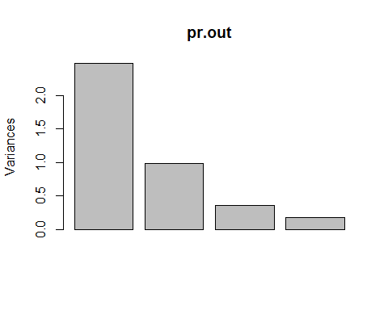

dim(pr.out$x)

## [1] 50 4

biplot(pr.out,scale=0)

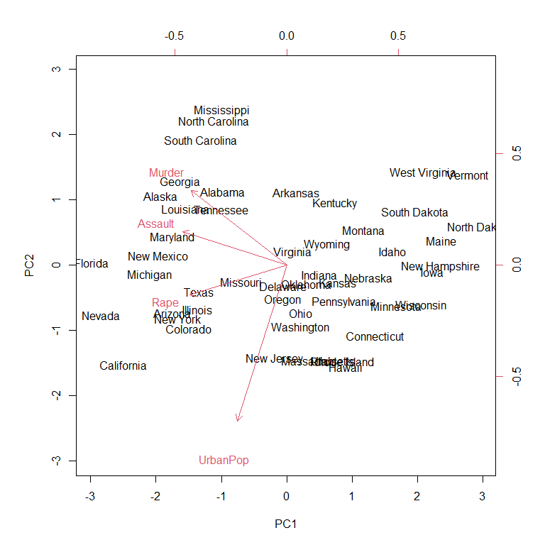

pr.out$rotation <- -pr.out$rotation  
pr.out$x <- -pr.out$x  
biplot(pr.out,scale=0)

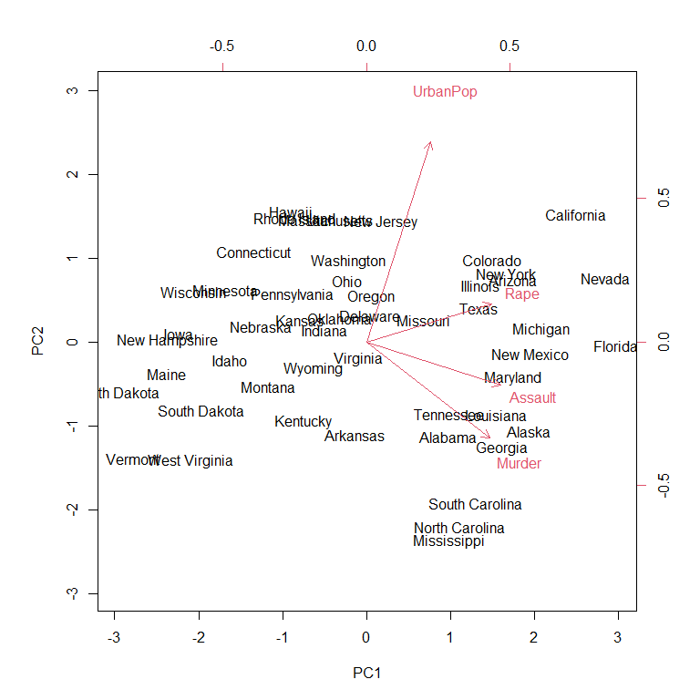

pr.out$sdev

## [1] 1.5748783 0.9948694 0.5971291 0.4164494

pr.var <- pr.out$sdev^2  
pr.var

## [1] 2.4802416 0.9897652 0.3565632 0.1734301

pve <- pr.var/sum(pr.var)  
pve

## [1] 0.62006039 0.24744129 0.08914080 0.04335752

plot(pve, xlab="Principal Component",ylab="Proportion of Variance Explained",ylim=c(0,1),type="b")

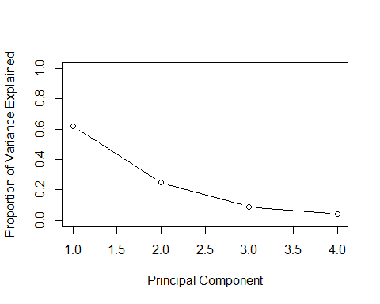

plot(cumsum(pve),xlab="Principal Component",ylab="Cummulative Proportion of Variance Explained",ylim=c(0,1),type="b")

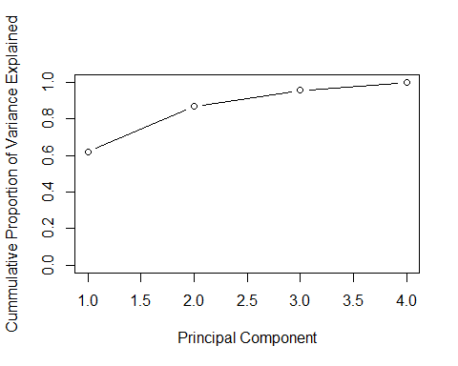

a <- c(1,2,8,-3)  
cumsum(a)

## [1] 1 3 11 8

# 10.5 Lab2: Clustering

## 10.5.1 K-Means Clustering

set.seed(2)  
x <- matrix(rnorm(50*2),ncol=2)  
x[1:25,1] <- x[1:25,1] + 3  
x[1:25,2] <- x[1:25,2] - 4  
plot(x)

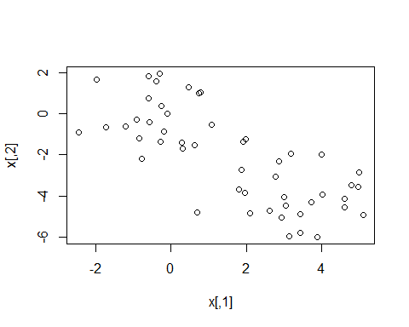

km.out <- kmeans(x,2,nstart=20)  
names(km.out)

## [1] "cluster" "centers" "totss" "withinss" "tot.withinss"  
## [6] "betweenss" "size" "iter" "ifault"

km.out$cluster

## [1] 1 1 1 1 1 1 1 1 1 1 1 1 1 1 1 1 1 1 1 1 1 1 1 1 1 2 2 2 2 2 2 2 2 2 2 2 2 2  
## [39] 2 2 2 2 2 2 2 2 2 2 2 2

plot(x,col=(km.out$cluster+1),main="K-Means Clustering Results with K=2",xlab="",ylab="",pch=20,cex=2)

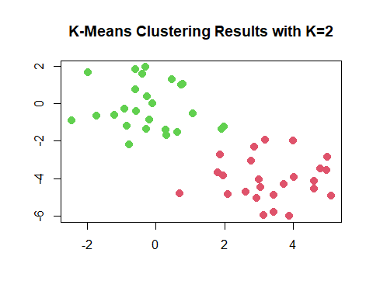

set.seed(4)  
km.out <- kmeans(x,3,nstart=20)  
km.out

## K-means clustering with 3 clusters of sizes 17, 23, 10  
##   
## Cluster means:  
## [,1] [,2]  
## 1 3.7789567 -4.56200798  
## 2 -0.3820397 -0.08740753  
## 3 2.3001545 -2.69622023  
##   
## Clustering vector:  
## [1] 1 3 1 3 1 1 1 3 1 3 1 3 1 3 1 3 1 1 1 1 1 3 1 1 1 2 2 2 2 2 2 2 2 2 2 2 2 2  
## [39] 2 2 2 2 2 3 2 3 2 2 2 2  
##   
## Within cluster sum of squares by cluster:  
## [1] 25.74089 52.67700 19.56137  
## (between_SS / total_SS = 79.3 %)  
##   
## Available components:  
##   
## [1] "cluster" "centers" "totss" "withinss" "tot.withinss"  
## [6] "betweenss" "size" "iter" "ifault"

plot(x,col=(km.out$cluster+1),main="K-Means Clustering Results with K=3",xlab="",ylab="",pch=20, cex=2)

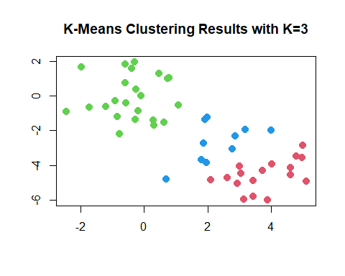

set.seed(3)  
km.out <- kmeans(x,3,nstart=1)  
km.out$tot.withinss

## [1] 97.97927

km.out <- kmeans(x,3,nstart=20)  
km.out$tot.withinss

## [1] 97.97927

## 10.5.2 Hierarchical Clustering

hc.complete <- hclust(dist(x),method="complete")

hc.average <- hclust(dist(x),method="average")  
hc.single <- hclust(dist(x),method="single")

par(mfrow=c(1,3))  
plot(hc.complete,main="Complete Linkage",xlab="",sub="",cex=.9)  
plot(hc.average,main="Average Linkage",xlab="",sub="",cex=.9)  
plot(hc.single,main="Single Linkage", xlab="",sub="",cex=.9)

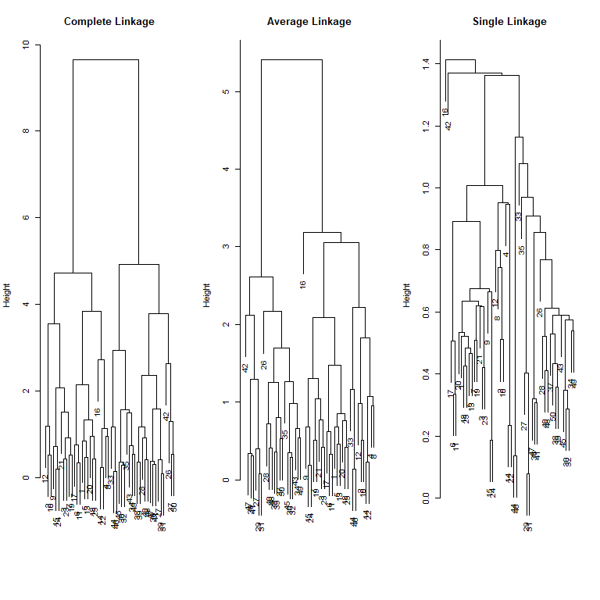

cutree(hc.complete,2)

## [1] 1 1 1 1 1 1 1 1 1 1 1 1 1 1 1 1 1 1 1 1 1 1 1 1 1 2 2 2 2 2 2 2 2 2 2 2 2 2  
## [39] 2 2 2 2 2 2 2 2 2 2 2 2

cutree(hc.average,2)

## [1] 1 1 1 1 1 1 1 1 1 1 1 1 1 1 1 1 1 1 1 1 1 1 1 1 1 2 2 2 2 2 2 2 1 2 2 2 2 2  
## [39] 2 2 2 2 2 1 2 1 2 2 2 2

cutree(hc.single,2)

## [1] 1 1 1 1 1 1 1 1 1 1 1 1 1 1 1 2 1 1 1 1 1 1 1 1 1 1 1 1 1 1 1 1 1 1 1 1 1 1  
## [39] 1 1 1 1 1 1 1 1 1 1 1 1

cutree(hc.single,4)

## [1] 1 1 1 1 1 1 1 1 1 1 1 1 1 1 1 2 1 1 1 1 1 1 1 1 1 3 3 3 3 3 3 3 3 3 3 3 3 3  
## [39] 3 3 3 4 3 3 3 3 3 3 3 3

xsc <- scale(x,center=F,scale=T)  
plot(hclust(dist(xsc),method="complete"),main="Hierarchical Clustering with Scaled Observations")

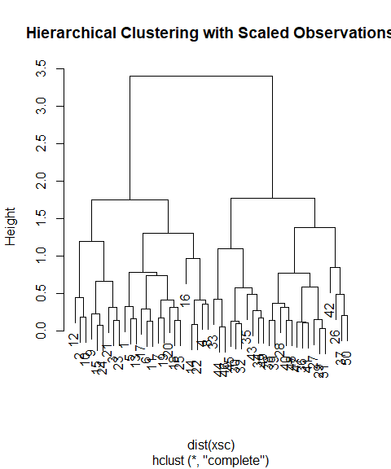

xsc <- scale(x)  
plot(hclust(dist(xsc),method="complete"),main="Hierarchical Clustering with Scaled Observations")

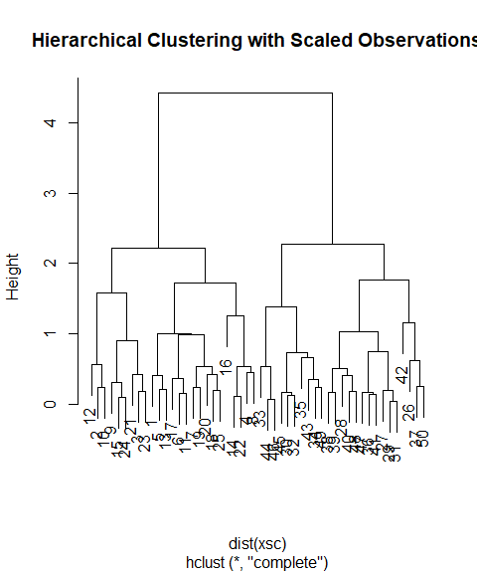

x <- matrix(rnorm(30*3),ncol=3)  
dd <- as.dist(1-cor(t(x)))  
plot(hclust(dd,method="complete"),main="Complete Linkage with Correlation-Based Distance",xlab="",sub="")

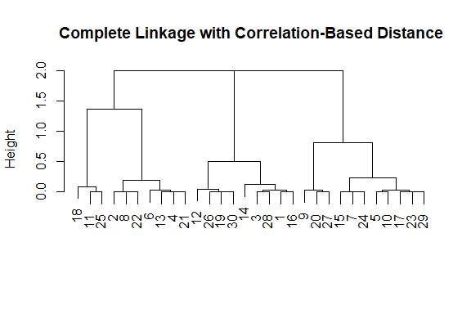

# 10.6 Lab3: NCI60 Data Example

library(ISLR)  
nci.labs <- NCI60$labs  
nci.data <- NCI60$data  
dim(nci.data)

## [1] 64 6830

nci.labs[1:4]

## [1] "CNS" "CNS" "CNS" "RENAL"

table(nci.labs)

## nci.labs  
## BREAST CNS COLON K562A-repro K562B-repro LEUKEMIA   
## 7 5 7 1 1 6   
## MCF7A-repro MCF7D-repro MELANOMA NSCLC OVARIAN PROSTATE   
## 1 1 8 9 6 2   
## RENAL UNKNOWN   
## 9 1

## 10.6.1 PCA on the NCI60 Data

pr.out <- prcomp(nci.data,scale=TRUE)

Cols <- function(vec){  
 cols=rainbow(length(unique(vec)))  
 return(cols[as.numeric(as.factor(vec))])  
}

par(mfrow=c(1,2))  
plot(pr.out$x[,1:2],col=Cols(nci.labs),pch=19,xlab="Z1",ylab="Z2")  
plot(pr.out$x[,c(1,3)],col=Cols(nci.labs),pch=19,xlab="Z1",ylab="Z3")

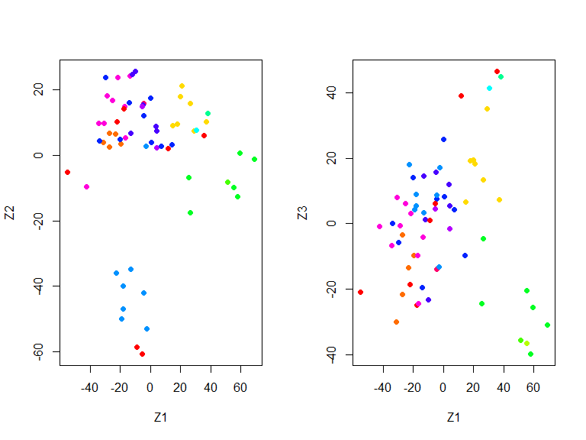

summary(pr.out)

## Importance of components:  
## PC1 PC2 PC3 PC4 PC5 PC6  
## Standard deviation 27.8535 21.48136 19.82046 17.03256 15.97181 15.72108  
## Proportion of Variance 0.1136 0.06756 0.05752 0.04248 0.03735 0.03619  
## Cumulative Proportion 0.1136 0.18115 0.23867 0.28115 0.31850 0.35468  
## PC7 PC8 PC9 PC10 PC11 PC12  
## Standard deviation 14.47145 13.54427 13.14400 12.73860 12.68672 12.15769  
## Proportion of Variance 0.03066 0.02686 0.02529 0.02376 0.02357 0.02164  
## Cumulative Proportion 0.38534 0.41220 0.43750 0.46126 0.48482 0.50646  
## PC13 PC14 PC15 PC16 PC17 PC18  
## Standard deviation 11.83019 11.62554 11.43779 11.00051 10.65666 10.48880  
## Proportion of Variance 0.02049 0.01979 0.01915 0.01772 0.01663 0.01611  
## Cumulative Proportion 0.52695 0.54674 0.56590 0.58361 0.60024 0.61635  
## PC19 PC20 PC21 PC22 PC23 PC24  
## Standard deviation 10.43518 10.3219 10.14608 10.0544 9.90265 9.64766  
## Proportion of Variance 0.01594 0.0156 0.01507 0.0148 0.01436 0.01363  
## Cumulative Proportion 0.63229 0.6479 0.66296 0.6778 0.69212 0.70575  
## PC25 PC26 PC27 PC28 PC29 PC30 PC31  
## Standard deviation 9.50764 9.33253 9.27320 9.0900 8.98117 8.75003 8.59962  
## Proportion of Variance 0.01324 0.01275 0.01259 0.0121 0.01181 0.01121 0.01083  
## Cumulative Proportion 0.71899 0.73174 0.74433 0.7564 0.76824 0.77945 0.79027  
## PC32 PC33 PC34 PC35 PC36 PC37 PC38  
## Standard deviation 8.44738 8.37305 8.21579 8.15731 7.97465 7.90446 7.82127  
## Proportion of Variance 0.01045 0.01026 0.00988 0.00974 0.00931 0.00915 0.00896  
## Cumulative Proportion 0.80072 0.81099 0.82087 0.83061 0.83992 0.84907 0.85803  
## PC39 PC40 PC41 PC42 PC43 PC44 PC45  
## Standard deviation 7.72156 7.58603 7.45619 7.3444 7.10449 7.0131 6.95839  
## Proportion of Variance 0.00873 0.00843 0.00814 0.0079 0.00739 0.0072 0.00709  
## Cumulative Proportion 0.86676 0.87518 0.88332 0.8912 0.89861 0.9058 0.91290  
## PC46 PC47 PC48 PC49 PC50 PC51 PC52  
## Standard deviation 6.8663 6.80744 6.64763 6.61607 6.40793 6.21984 6.20326  
## Proportion of Variance 0.0069 0.00678 0.00647 0.00641 0.00601 0.00566 0.00563  
## Cumulative Proportion 0.9198 0.92659 0.93306 0.93947 0.94548 0.95114 0.95678  
## PC53 PC54 PC55 PC56 PC57 PC58 PC59  
## Standard deviation 6.06706 5.91805 5.91233 5.73539 5.47261 5.2921 5.02117  
## Proportion of Variance 0.00539 0.00513 0.00512 0.00482 0.00438 0.0041 0.00369  
## Cumulative Proportion 0.96216 0.96729 0.97241 0.97723 0.98161 0.9857 0.98940  
## PC60 PC61 PC62 PC63 PC64  
## Standard deviation 4.68398 4.17567 4.08212 4.04124 2.148e-14  
## Proportion of Variance 0.00321 0.00255 0.00244 0.00239 0.000e+00  
## Cumulative Proportion 0.99262 0.99517 0.99761 1.00000 1.000e+00

plot(pr.out)

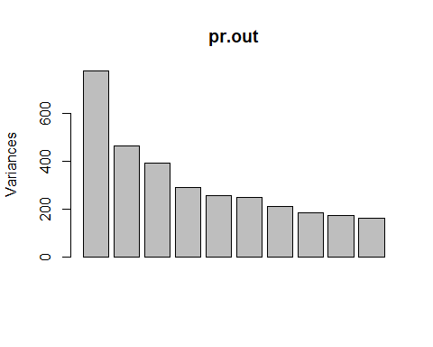

pve <- 100*pr.out$sdev^2/sum(pr.out$sdev^2)  
par(mfrow=c(1,2))  
plot(pve, type="o",ylab="PVE",xlab="Principal Component",col="blue")  
plot(cumsum(pve),type="o",ylab="Cummulative PVE",xlab="Principal Component",col="brown3")

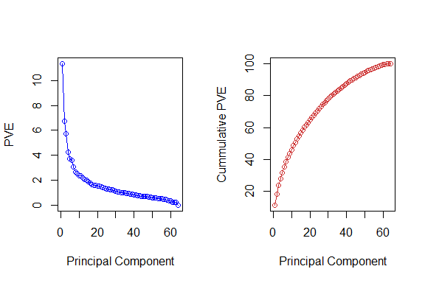

## 10.6.2 Clustering the Observations of the NCI60 Data

sd.data <- scale(nci.data, FALSE, TRUE)  
par(mfrow=c(1,3))  
data.dist <- dist(sd.data)  
plot(hclust(data.dist),labels=nci.labs,main="Complete Linkage",xlab="",sub="",ylab="")  
plot(hclust(data.dist,method="average"),labels=nci.labs,main="Average Linkage",xlab="",sub="",ylab="")  
plot(hclust(data.dist,method="single"),labels=nci.labs,main="Single Linkage",xlab="",sub="",ylab="")

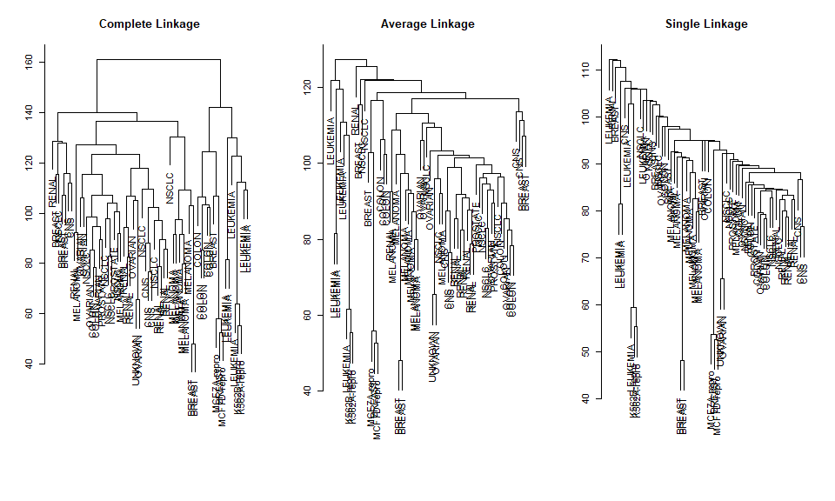

hc.out <- hclust(dist(sd.data))  
hc.clusters <- cutree(hc.out,4)  
table(hc.clusters,nci.labs)

## nci.labs  
## hc.clusters BREAST CNS COLON K562A-repro K562B-repro LEUKEMIA MCF7A-repro  
## 1 2 3 2 0 0 0 0  
## 2 3 2 0 0 0 0 0  
## 3 0 0 0 1 1 6 0  
## 4 2 0 5 0 0 0 1  
## nci.labs  
## hc.clusters MCF7D-repro MELANOMA NSCLC OVARIAN PROSTATE RENAL UNKNOWN  
## 1 0 8 8 6 2 8 1  
## 2 0 0 1 0 0 1 0  
## 3 0 0 0 0 0 0 0  
## 4 1 0 0 0 0 0 0

par(mfrow=c(1,1))  
plot(hc.out,labels=nci.labs)  
abline(h=139,col="red")

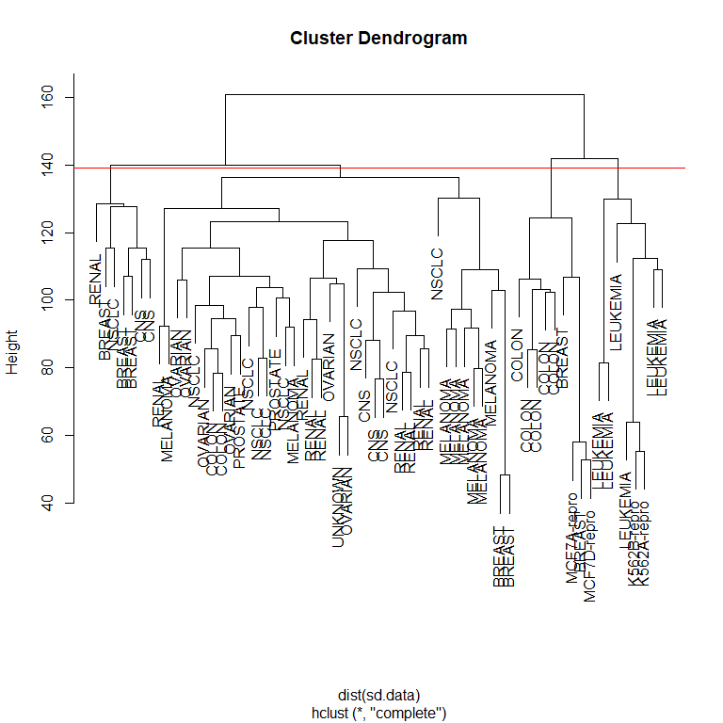

hc.out

##   
## Call:  
## hclust(d = dist(sd.data))  
##   
## Cluster method : complete   
## Distance : euclidean   
## Number of objects: 64

set.seed(2)  
km.out <- kmeans(sd.data,4,nstart=20)  
km.clusters <- km.out$cluster  
table(km.clusters,hc.clusters)

## hc.clusters  
## km.clusters 1 2 3 4  
## 1 11 0 0 9  
## 2 20 7 0 0  
## 3 9 0 0 0  
## 4 0 0 8 0

hc.out <- hclust(dist(pr.out$x[,1:5]))  
plot(hc.out,labels=nci.labs,main="Hier. Clust. on First Five Score Vectors")

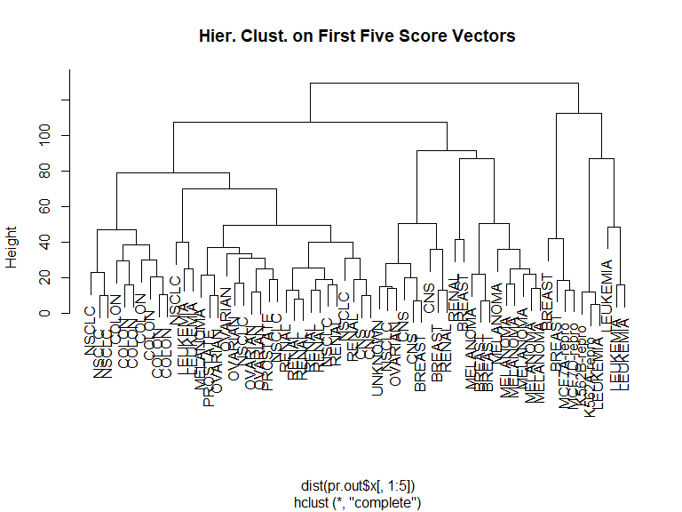

table(cutree(hc.out,4),nci.labs)

## nci.labs  
## BREAST CNS COLON K562A-repro K562B-repro LEUKEMIA MCF7A-repro MCF7D-repro  
## 1 0 2 7 0 0 2 0 0  
## 2 5 3 0 0 0 0 0 0  
## 3 0 0 0 1 1 4 0 0  
## 4 2 0 0 0 0 0 1 1  
## nci.labs  
## MELANOMA NSCLC OVARIAN PROSTATE RENAL UNKNOWN  
## 1 1 8 5 2 7 0  
## 2 7 1 1 0 2 1  
## 3 0 0 0 0 0 0  
## 4 0 0 0 0 0 0